
WEb design and development
Lab manual

Gc women university sialkot

Submitted by: Manahil Abid
Class: BS-IT
Semester: 5th
Roll no: BS-IT-F23-R010
Course Title: Web Design And Development
Submitted to: Mam Shaista

Lab#01
Task#01
Visual code studio installation
- Download and run Visual Studio Code installer from http://code.visualstudio.com/Download.

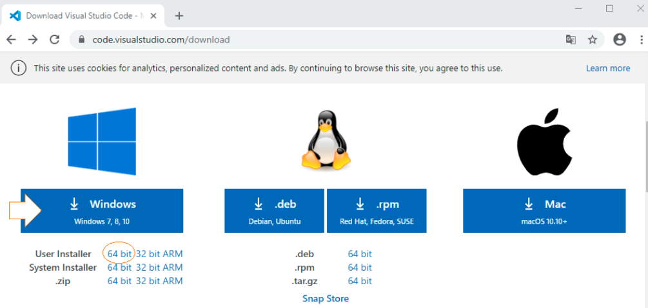
- Accept the license terms.
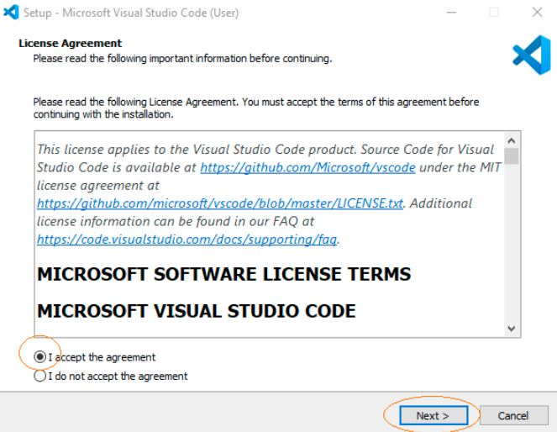
- In the following window, check a. “Add to PATH (available after restart)” and b. “Run Code after installation”.Click on Next.
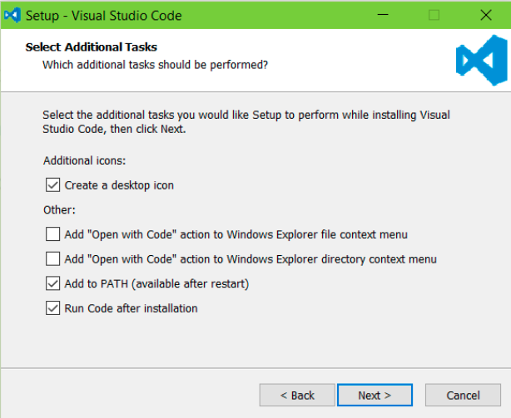
- Wait for installation to complete and click on Finish.

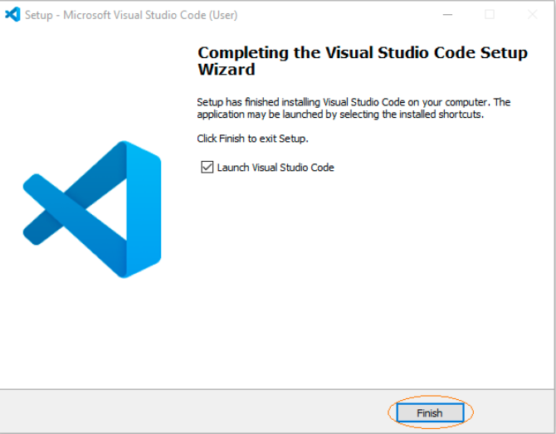

- Interface of VS code:
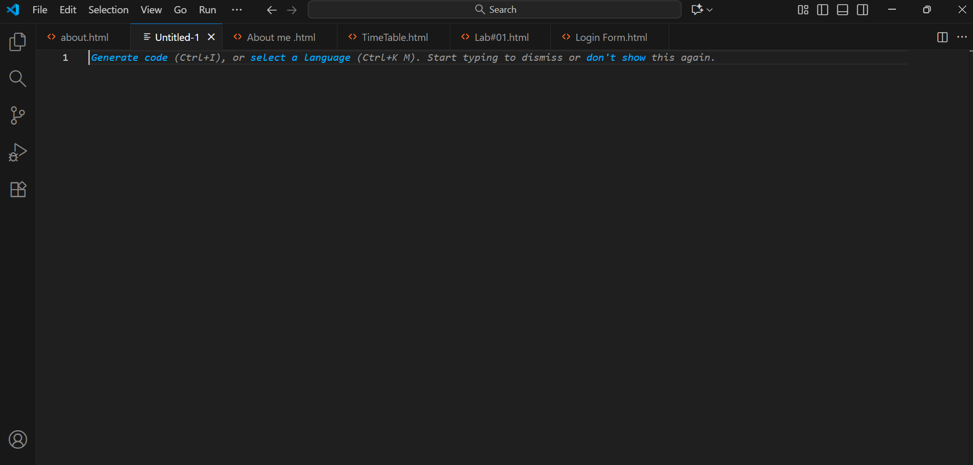

Lab#02
Task#01
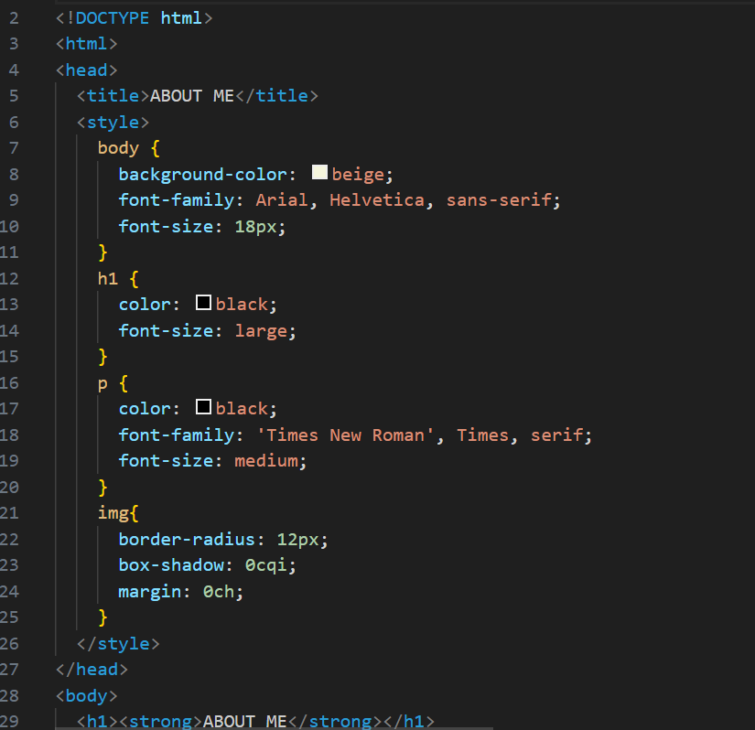
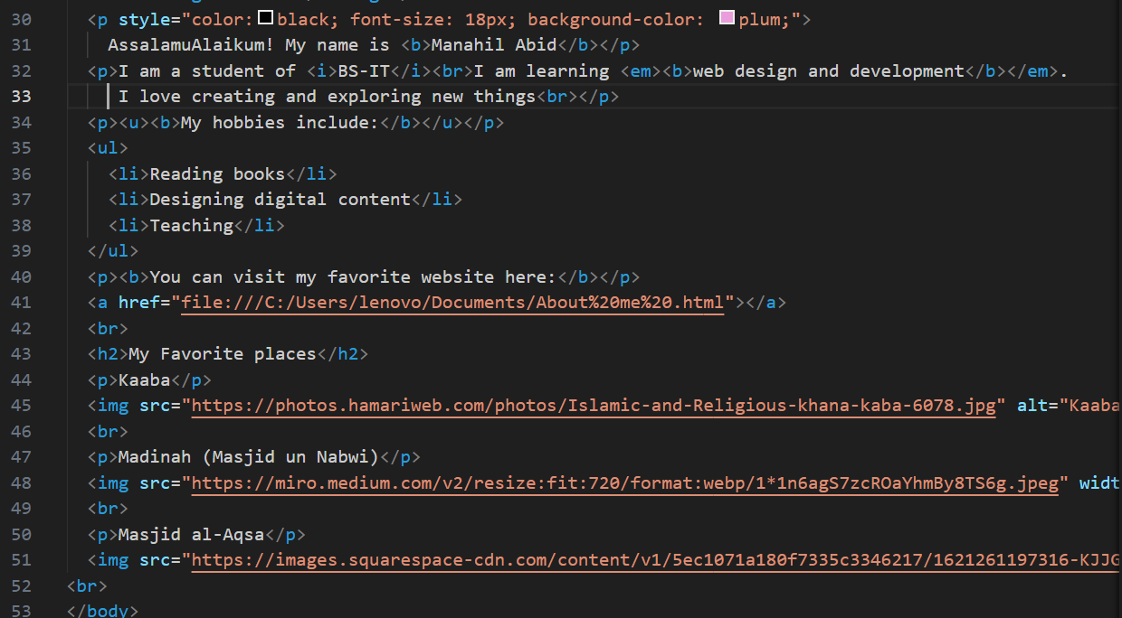
Code Detail:
This html code creates a personal "about me" webpage, combining internal css for styling the overall page, text, and images, with standard html structure and content.
🎨 Internal CSS styling (<style>)
The css rules are defined in the <head> section and apply globally to the specified elements:
- body selector:
  - background-color: beige;: sets the page background to a beige color.
  - font-family: arial, helvetica, sans-serif;: sets the default font to arial.
  - font-size: 18px;: sets the default text size for the body.
- h1 selector:
  - color: black;: sets the <h1> text color to black.
  - font-size: large;: sets the <h1> font size (though large is relative and often smaller than the default browser <h1> size).
- p selector:
  - color: black;: sets the default paragraph text color to black.
  - font-family: 'times new roman', times, serif;: sets the paragraph text font to times new roman.
  - font-size: medium;: sets the paragraph text size.
- img selector:
  - border-radius: 12px;: rounds the corners of all images by 12 pixels.
  - box-shadow: 0cqi;: invalid/incomplete css property. it likely results in no effect.
  - margin: 0ch;: invalid/incomplete css property. it likely results in no margin.

📄 HTML content (<body>)
the visible content section contains personal information, links, and images:
- Main heading and introduction:
  - <h1><strong>about me</strong></h1>: the main, bold title of the page.
  - first paragraph: uses inline styling (style="...") which overrides the general p css rule for this paragraph only:
    - color:black; font-size: 18px; background-color: plum;: sets the background to plum for this paragraph specifically.
    - contains the greeting and bolded name (<b>manahil abid</b>).
  - second paragraph: contains student details, using <i> for italics and a combination of <b> and <em> for strong emphasis.
- Hobbies list:
  - <u><b>my hobbies include:</b></u>: a paragraph heading that is both underlined and bolded.
  - <ul>...</ul>: an unordered (bulleted) list of hobbies.
- Hyperlink:
  - <a href="file:///c:/users/.../about%20me%20.html"></a>: an anchor tag that points to a local file path on the user's computer. importantly, the link text is missing between the <a> and </a> tags, so it will not be visible or clickable on the page.
- Favorite places section:
  - <h2>my favorite places</h2>: a level 2 subheading.
  - the section lists three holy sites: kaaba, madinah (masjid un nabwi), and masjid al-aqsa.
  - images: three images are embedded using web urls (src="...").
    - all images are scaled down using the width="300" attribute (one also uses height="400").
    - all images will have rounded corners due to the img css selector.
  - <br> tags: used repeatedly to ensure line breaks and vertical spacing between the items.
- Output Page:
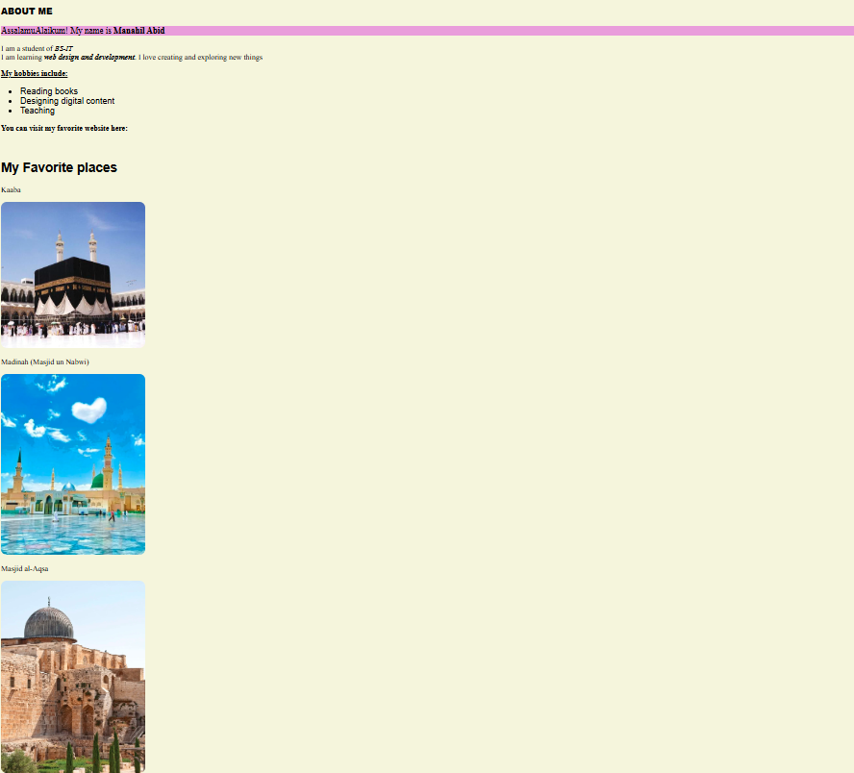
Task#02
Code:
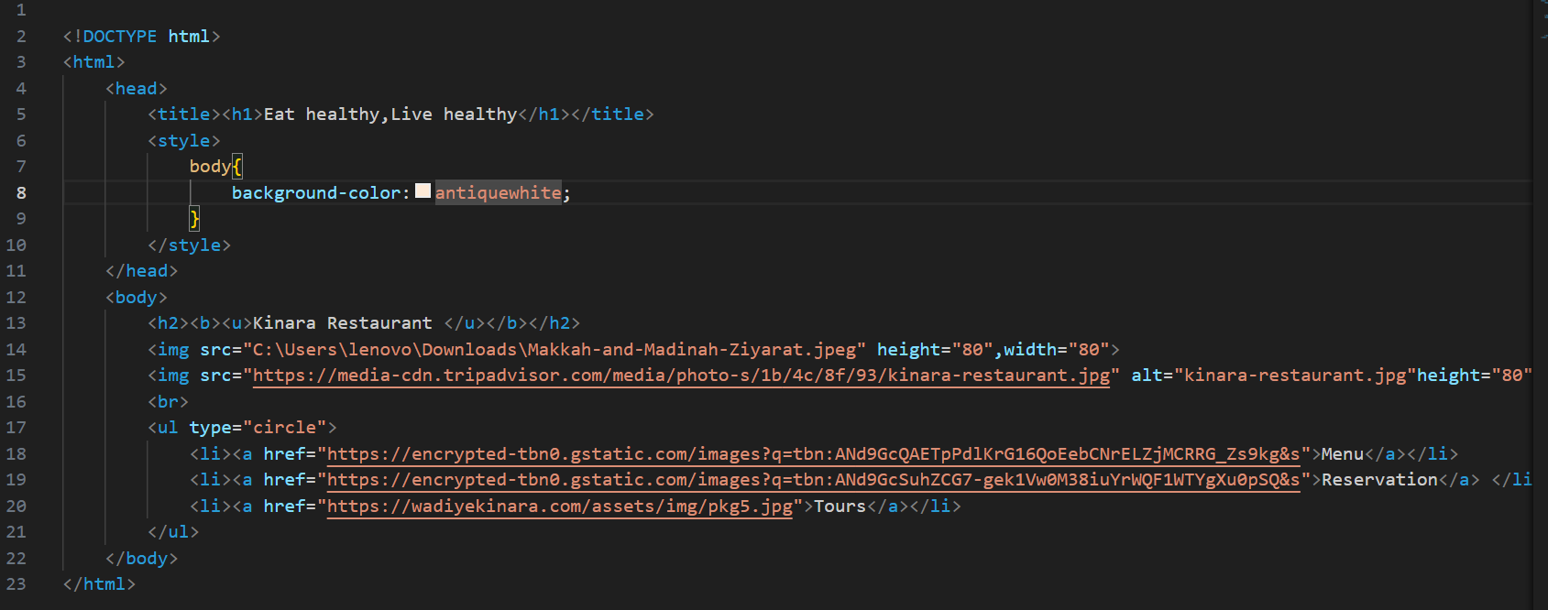
Code Detail:
This html code creates a simple webpage for a restaurant called "kinara restaurant." it includes basic structure, internal styling, images, and an unordered list of navigation links.

Code structure and styling 📝
- Line 1-2 (<!doctype html>, <html>): defines the document as html5 and starts the root element.
- Line 3-10 (<head>...</head>): contains metadata and styling information.
  - Line 4 (<title>): sets the browser tab title to literally <h1>eat healthy,live healthy</h1>. note that nesting an <h1> tag inside the <title> tag is unusual and not standard practice; the browser will likely display the raw html tag text in the tab.
  - Line 5-9 (<style>...</style>): defines internal css.
    - line 6-8 (body{...}): targets the <body> element and sets the background color of the entire visible page to antiquewhite.

Visible page content (<body>) 🍽️
- Line 11 (<body>): starts the visible content of the page.
- Line 12 (<h2>): displays the main heading "kinara restaurant" as a level 2 heading. the text is made bold (<b>) and underlined (<u>).
- Line 13 (<img src="...">): embeds the first image.
  - the src uses a local file path (c:\users\...), meaning the image will likely only load correctly on the author's computer.
  - sets the size to 80x80 pixels.
- Line 14 (<img src="...">): embeds the second image.
  - the src uses a web url (https://...), which is the standard way to reference an external image.
  - the alt attribute provides alternative text for accessibility.
  - sets the size to 80x80 pixels.
- Line 15 (<br>): inserts a single line break after the images.
- Line 16-20 (<ul>...</ul>): creates an unordered (bulleted) list.
  - type="circle": sets the bullet style to a filled circle.
  - Line 17-19 (<li><a>...</a></li>): contains three list items, each with an anchor tag (<a>) creating a hyperlink.
    - the links are labeled menu, reservation, and tours, each pointing to a different external image or webpage url via the href attribute.

Output Page:
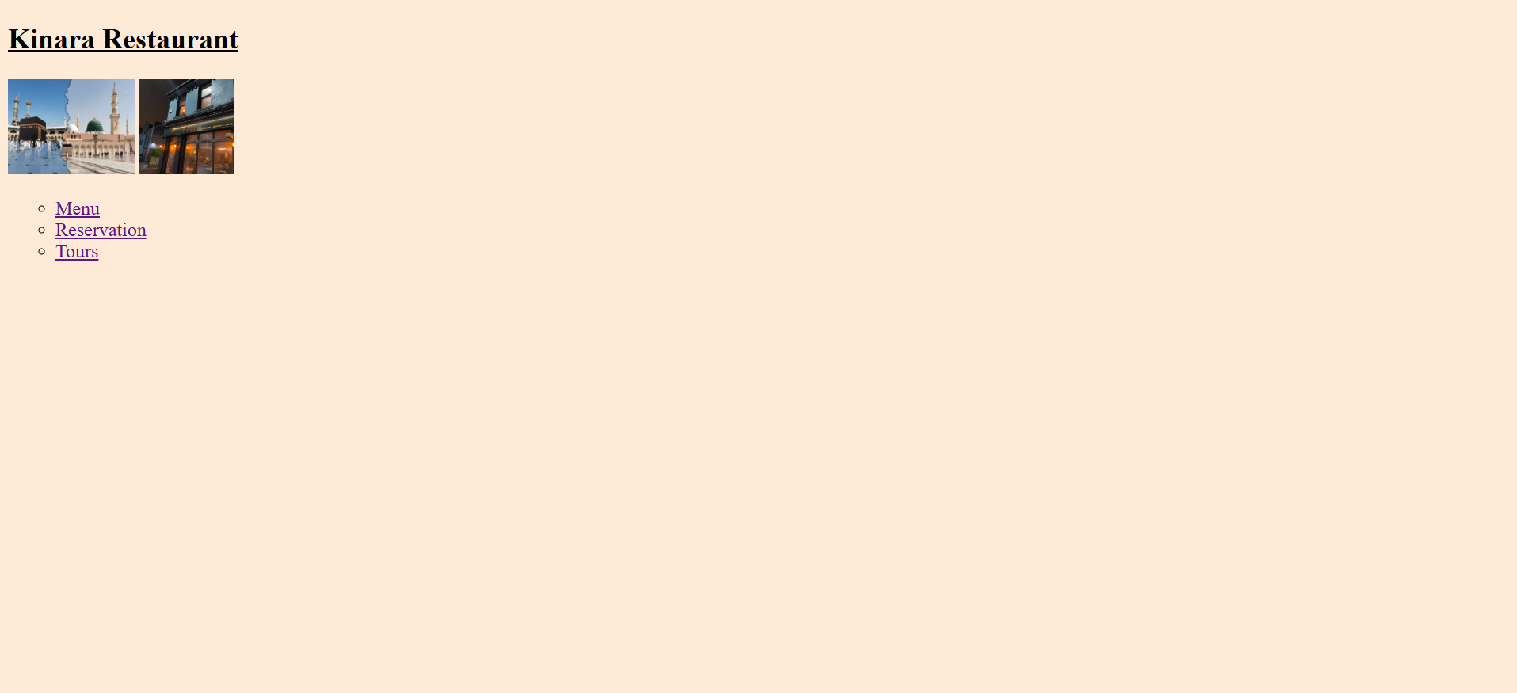
lab#03
task#1
class timetable
code:
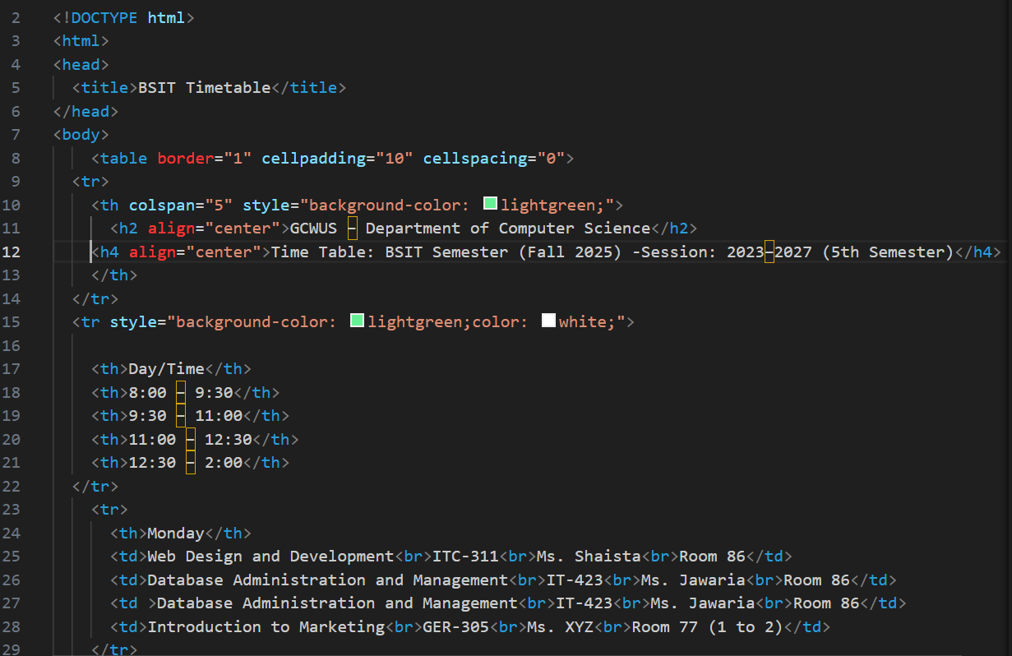
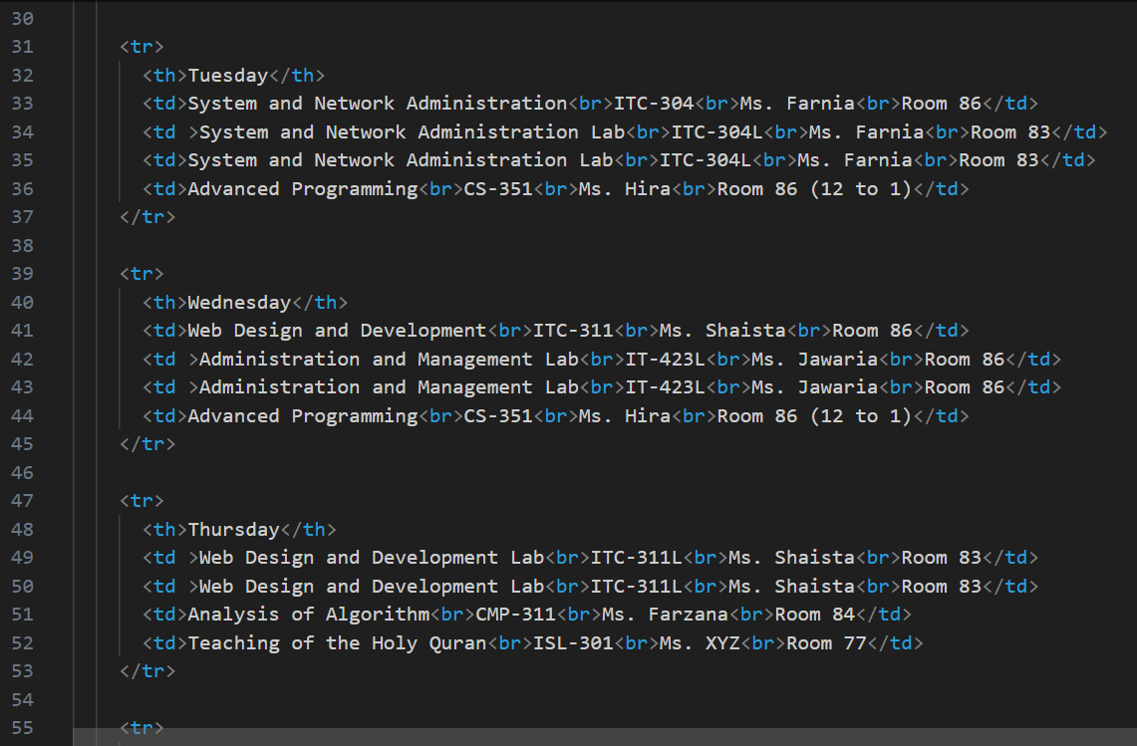
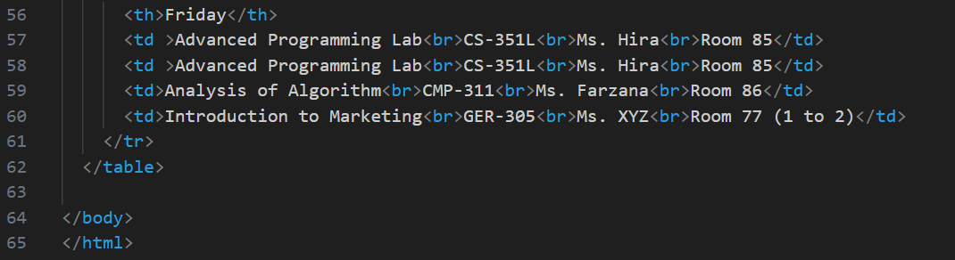
CODE DETAIL:
This html code defines a comprehensive ACADEMIC TIMETABLE using a structured <table> element, styled with basic html attributes.
📅 Timetable Structure Detail
The code uses the <table> tag to create the grid structure of the timetable, with several key attributes and sections:
1. Table Setup (<table>)
- border="1": Adds a 1-pixel border around the entire table and all its cells.
- cellpadding="10": Adds 10 pixels of padding (space) inside each cell, between the cell content and the cell border.
- cellspacing="0": Removes the default space between adjacent cells, making the borders touch.

2. Header Block (<tr> with colspan)
This is the very first row, spanning the full width of the table.
- <th colspan="5" ...>: The single cell uses colspan="5" to merge the cell across all 5 columns.
- style="background-color: lightgreen;": Applies a light green background to the merged header cell.
- Content: It contains two nested, centered headings (<h2> and <h4>) that display the institution name (gcwus – department of computer science) and the timetable details (BSIT 5th semester).

3. Column Headers (<tr> with Styling)
This row defines the top row headers for the days and time slots.
- style="background-color: lightgreen; color: white;": Applies a light green background and sets the text color to white for the entire row.
- Headers (<th>): Defines the five column headings: day/time, 8:00 – 9:30, 9:30 – 11:00, 11:00 – 12:30, and 12:30 – 2:00.

4. Data Rows (Monday to Friday)
The remaining five rows (<tr>) represent the schedule for monday through friday.
- Row Header (<th>): Each row starts with a <th> cell (monday, tuesday, etc.) to label the row.
- Data Cells (<td>): The remaining four cells (<td>) in each row contain the course information for the respective time slot.
  - Content Format: Each time slot cell holds four lines of data, separated by the <br> (line break) tag:
    - Course Name (e.g., web design and development)
    - Course Code (e.g., ITC-311)
    - Instructor Name (e.g., Ms. Shaista)
    - Room Number (e.g., Room 86)
- Output Page:
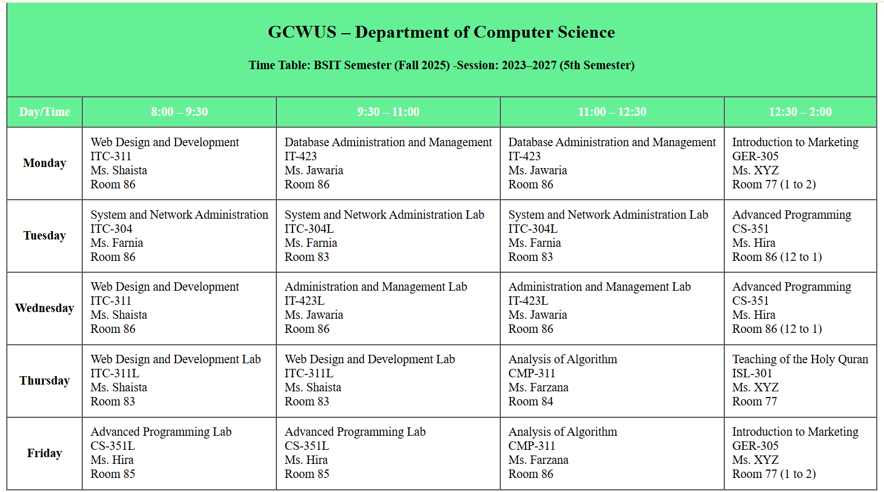
Task#2
student registration Form
Code:
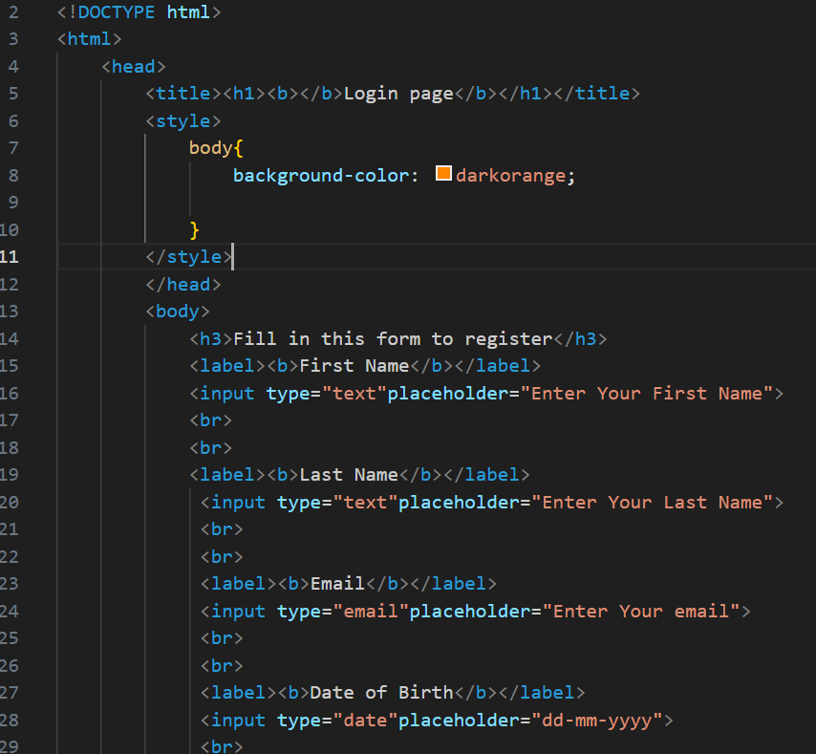
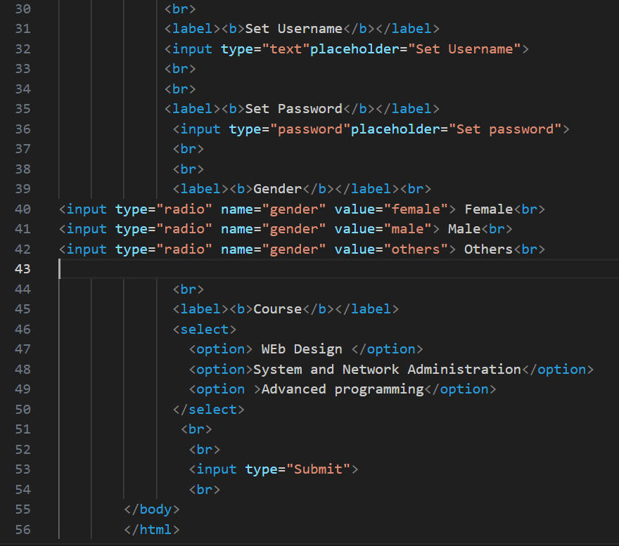
Code Detail:
This html code defines a basic registration form with a variety of input fields, utilizing internal css for basic styling.

Code structure and styling 🎨
- line 4 (<title>): sets the browser tab title to "login page". note that the unnecessary <h1> and <b> tags are mistakenly included inside the <title> tag, but modern browsers usually ignore them in this context and display only the text.
- line 7 (css): inside the <style> block (internal css), the property background-color: darkorange; sets the background of the entire visible page (<body>) to dark orange.

Form content (<body>) 📝
The body focuses on creating various fields typically found in a registration or login form:
- line 12 (<h3>): displays the instructional text "fill in this form to register" as a level 3 heading.
- line 13 (<label>): the label tag is introduced. it defines a caption ("first name") for a user interface element. using <b> makes the text bold.
- line 14 (<input type="text">): the input tag is used for the first time.
  - type="text": creates a standard single-line text input field.
  - placeholder="enter your first name": provides hint text inside the empty field.
- line 15, 17 (<br>): inserts a single line break for vertical spacing.
- line 19 (<input type="email">): creates an input field specifically for an email address. browsers may perform basic validation (checking for '@' symbol) before submission.
- line 23 (<input type="date">): creates an input field for a date. modern browsers typically display an interactive calendar picker for this field type.
- line 27 (<input type="password">): creates an input field where the characters typed are masked (displayed as dots or asterisks) for privacy.
- line 32 (<input type="radio" name="gender" value=" male/female/other">): creates a radio button. this input type is used when the user must choose only one option from a set (e.g., male/female).
- line 38 (<select>): the select tag is introduced to create a drop-down list (or dropdown menu).
- line 39 (<option>): the option tag defines an individual item ("web design") that can be selected within the parent <select> list.
- line 43 (<input type="submit">): creates a button labeled "submit" that is designed to send the form data to a server (though the required <form> tag wrapper is missing here).
Output Page:
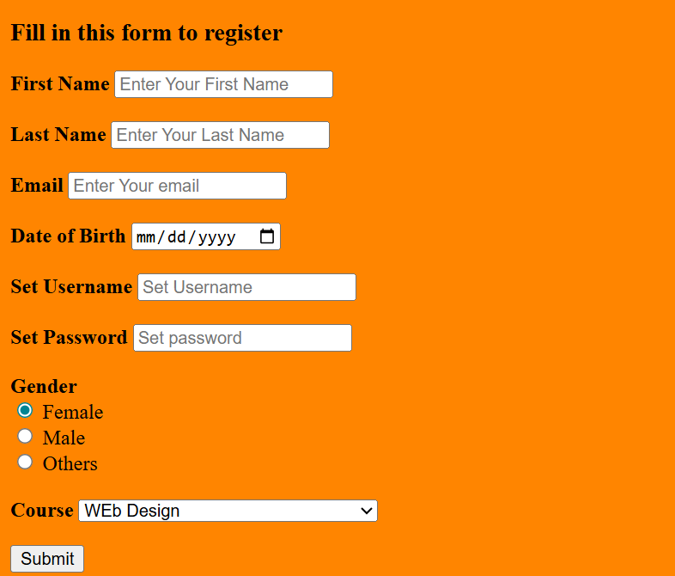

Lab#04
Task#1
- Q1: Create a simple div with an id "box". Add some text content inside the div. Set its background color to blue.
Code:
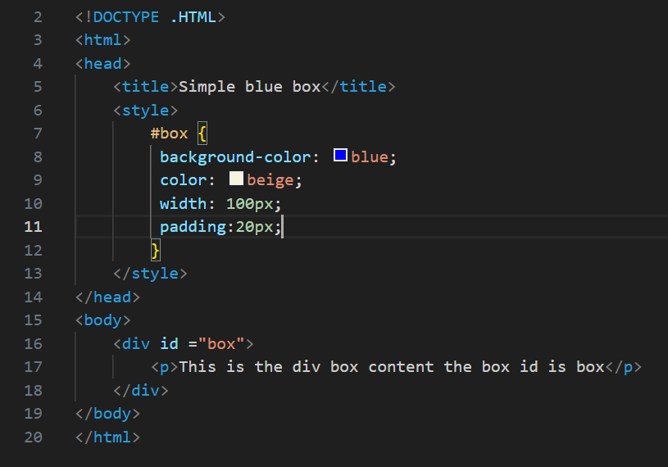
🎨 Code detail:
This code creates a basic webpage that displays a small blue rectangular box containing text, styled using Internal CSS to demonstrate the use of an ID selector.

🎨 Internal CSS Styling (<style>)
The styles are defined inside the <head> section, specifically targeting the element with the ID "box":
- #box Selector: This ID selector targets the single HTML element that has the attribute id="box".
  - background-color: blue;: Sets the background color of the box to blue.
  - color: beige;: Sets the text color inside the box to beige for contrast.
  - width: 100px;: Sets the width of the content area of the box to 100 pixels.
  - padding: 20px;: Adds 20 pixels of space inside the box, between the content and the border (if one were present).

📄 HTML Structure (<body>)
The visible content section defines the styled element:
- <div id ="box">...</div>: A Division element (<div>) is created, and it is assigned the unique identifier id="box". This ID links it directly to the CSS rule defined above.
- <p>...</p>: A paragraph tag is nested inside the div. This is the content that will be displayed inside the blue box.
  - The text is: "This is the div box content the box id is box".
In summary, the code defines a specific, uniquely identifiable content block (div) and applies distinct size, padding, and color styles to it using an ID selector.

- Output Page:
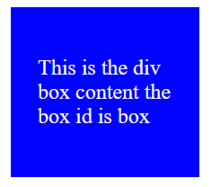
Task#2
- Create html document with head tag having title named Lab3 Task and also create body with h1,h2,h3 headings
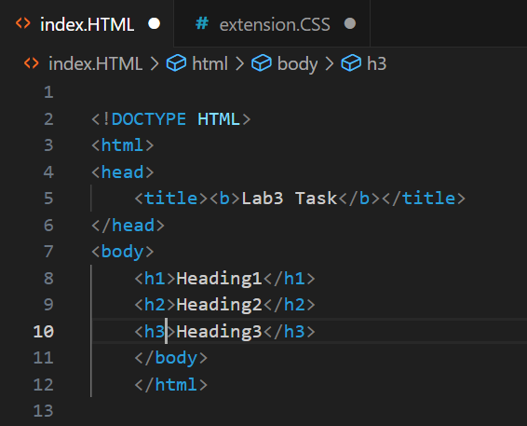
Code Detail

This is a minimal, well-formed HTML5 document that defines a webpage structure containing a title and three distinct headings.

- <!DOCTYPE HTML>: This is the Document Type Declaration and must be the very first line. It tells the browser that the document should be interpreted as HTML5.
- <html>...</html>: This is the root element that wraps all the content on the page.
- <head>...</head>: This section contains metadata—information about the HTML document that isn't displayed on the page itself.
  - <title>Lab3 Task</title>: This tag sets the text that appears on the browser's tab or window title bar.
- <body>...</body>: This section contains the visible page content that users see in the browser window.
  - <h1>Heading1</h1>: Displays "Heading1" as the most important (largest) heading.
  - <h2>Heading2</h2>: Displays "Heading2" as a secondary heading, visually smaller than <h1>.
  - <h3>Heading3</h3>: Displays "Heading3" as a third-level heading, visually smaller than <h2>.
The code successfully creates a standard webpage structure and displays three hierarchical headings in the main content area.
Output:
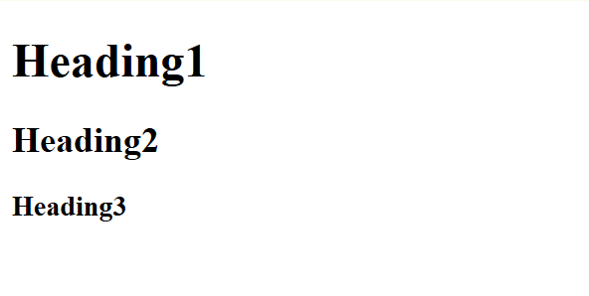
Apply inline CSS :
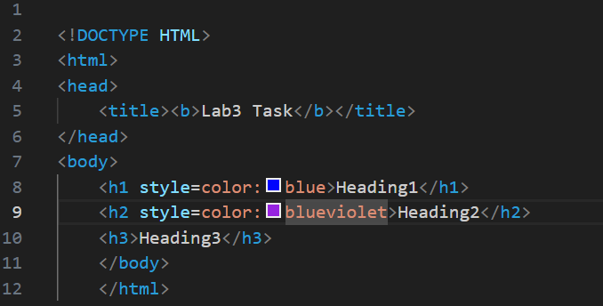
Code changes detail
The changes involve applying inline CSS (Cascading Style Sheets) to the first two heading elements to change their text color.

The following changes were made inside the <body> of the HTML:
- <h1> Element Change:
  - Original: <h1>Heading1</h1>
  - New: <h1 style=color:blue>Heading1</h1>
  - Detail: An style attribute was added to the <h1> tag. The value color:blue sets the text color of "Heading1" to blue.
- <h2> Element Change:
  - Original: <h2>Heading2</h2>
  - New: <h2 style=color:blueviolet>Heading2</h2>
  - Detail: An style attribute was added to the <h2> tag. The value color:blueviolet sets the text color of "Heading2" to blueviolet.
- <h3> Element Status:
  - The <h3>Heading3</h3> element remains unchanged and will display in the browser's default text color (usually black).
In summary, the code now uses inline styling to override the default text color for the <h1> and <h2> elements.

Output:
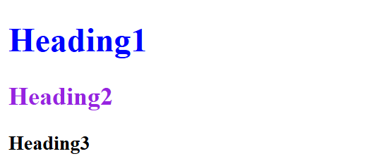
Apply internal CSS :
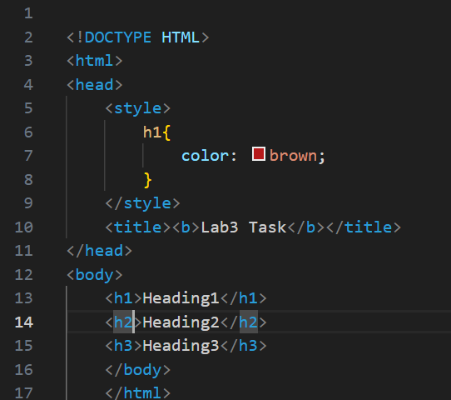

Code Changes Detail 🎨
The changes primarily involve the introduction of Internal CSS to style the <h1> element
- <style> Tag Added:
  - A <style> tag was inserted inside the <head> section. This is used to define Internal CSS, meaning the styles are embedded directly within the HTML document.
- CSS Rule Defined:
  - A CSS rule h1 { color: brown; } was placed within the <style> block.
  - Detail: This rule selects the <h1> element and sets its text color property to brown.
- Effect:
  - The text of "Heading1" will now display in brown.
  - The <h2> and <h3> elements remain in their default color (usually black) as they have no style applied.
This change demonstrates a shift from inline styling (using the style attribute on the element itself, as in a previous version) to Internal Styling for applying design rules.
Output:
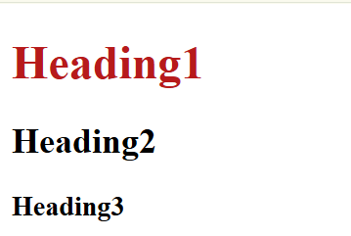

Applying both inline and internal CSS:
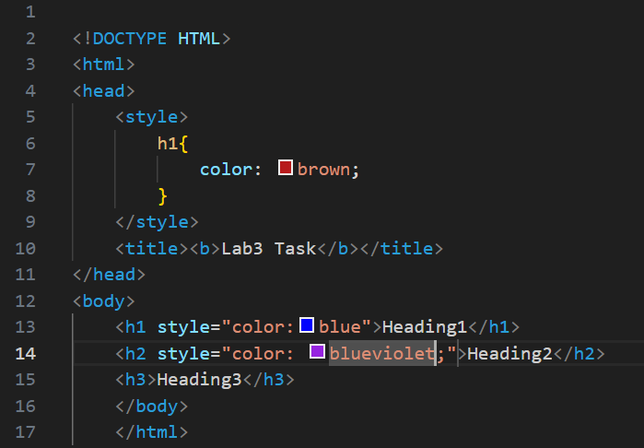
Code Changes Detail 🔄
The changes involve applying inline CSS to the <h1> and <h2> elements, which overrides the previously defined Internal CSS for <h1>.

- <h1> Element Change:
  - Inline Style Added: The attribute style="color:blue" was added to the <h1> tag.
  - Effect: The text "Heading1" will display in blue. This overrides the Internal CSS rule (h1 { color: brown; }) due to the higher precedence of inline styles in CSS specificity.
- <h2> Element Change:
  - Inline Style Added: The attribute style="color: blueviolet;" was added to the <h2> tag.
  - Effect: The text "Heading2" will display in blueviolet.
The code now demonstrates the cascade effect of CSS, where more specific inline styles take precedence over less specific internal styles.
Output:

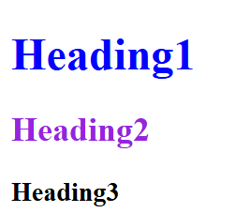
Applying external CSS:
HTML file:

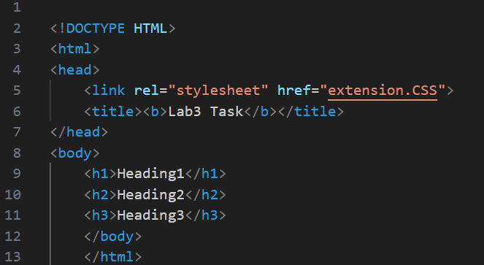
CSS file:

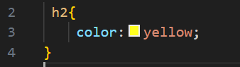
Code Changes Detail 🔗
The change involves removing the Internal and Inline CSS and introducing a link to an External Stylesheet, while an External CSS rule is also defined
- External CSS Link Added:
  - A new tag <link rel="stylesheet" href="extension.CSS"> was inserted into the <head>.
  - Detail: This establishes a link to an External Stylesheet named extension.CSS. The browser will now look for and apply styles defined in that external file.
- External CSS Rule Defined(The Type selector is used):
  - The external file (extension.CSS) contains the rule h2 { color: yellow; } (type selector that directly apply on tag.
  - Effect: This rule attempts to set the color of the <h2> element to yellow.
Output:
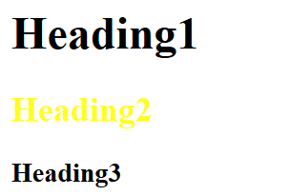

Applying both inline and external CSS:
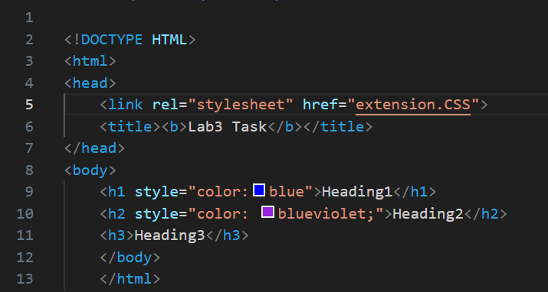
Code Changes Detail 🔗
The change involves removing the Internal CSS and introducing a link to an External Stylesheet, while an External CSS rule is also defined.

- Internal CSS Removed:
  - The entire <style>...</style> block, which previously set h1 color to brown, has been removed from the <head>.
- External CSS Link Added:
  - A new tag <link rel="stylesheet" href="extension.CSS"> was inserted into the <head>.
  - Detail: This establishes a link to an External Stylesheet named extension.CSS. The browser will now look for and apply styles defined in that external file.
- External CSS Rule Defined:
  - The external file (extension.CSS) contains the rule h2 { color: yellow; }.
  - Effect: This rule attempts to set the color of the <h2> element to yellow.
- Final Display Result:
  - The inline style on the <h2> element (style="color: blueviolet;") has the highest precedence in CSS. Therefore, "Heading2" will still display in blueviolet, overriding the yellow color defined in the external file.
  - "Heading1" remains blue (from its inline style).
  - "Heading3" remains its default color (usually black).

External CSS:
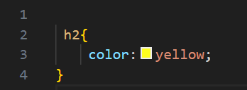
Output:

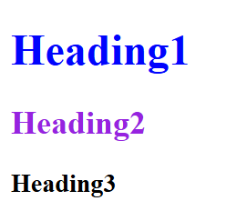
Applying Universal selector:
HTML file:

CSS File

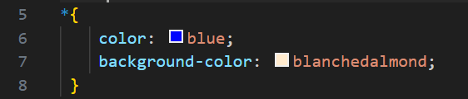
Code Changes Detail 📝
The changes involve defining an External CSS rule using the Universal Selector (*).

- External CSS Rule Defined (Universal Selector):
  - The external file (extension.CSS) now contains the following rule:
CSS
* {
color: blue;
background-color: blanchedalmond;
}
  - Detail: The Universal Selector (*) selects every single element in the HTML document (including <html>, <body>, <h1>, <h2>, <h3>, etc.).
  - Effect:
    - The text of all elements (including "Heading1", "Heading2", and "Heading3") will be set to blue.
    - The background color of the entire page and all its elements will be set to blanchedalmond.
The code now relies completely on the External Stylesheet to globally style the entire page content.
Output:

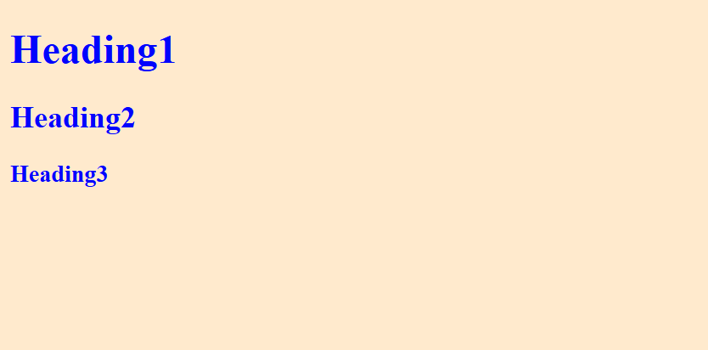
Applying class selector:
HTML file:
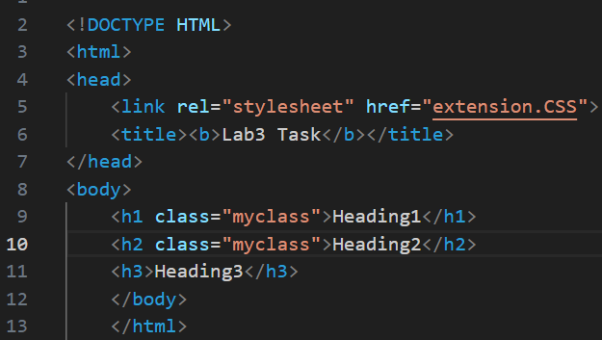
CSS File
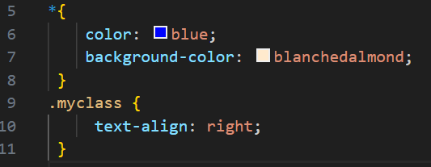
Code Changes Detail ✨
The changes involve introducing a CSS Class Selector and applying it to the first two headings, alongside the existing Universal Selector rule.

- CSS Class Added to Elements:
  - The attribute class="myclass" was added to both the <h1> and <h2> elements.
  - Effect: These two headings are now grouped under the custom class name myclass.
- New External CSS Rule:
  - A new rule for the class selector .myclass was added to the external file (extension.CSS):
CSS
.myclass {
text-align: right;
}
  - Detail: The .myclass selector targets only the elements with that class name (<h1> and <h2>). The property text-align: right is applied.
  - Effect: "Heading1" and "Heading2" will now be aligned to the right of the browser window.
- Overall Result:
  - The Universal Selector (*) still applies its styles globally: all text is blue and the background is blanchedalmond.
  - The Class Selector then applies its more specific style: "Heading1" and "Heading2" are right-aligned, while "Heading3" remains left-aligned (the default).
Output:

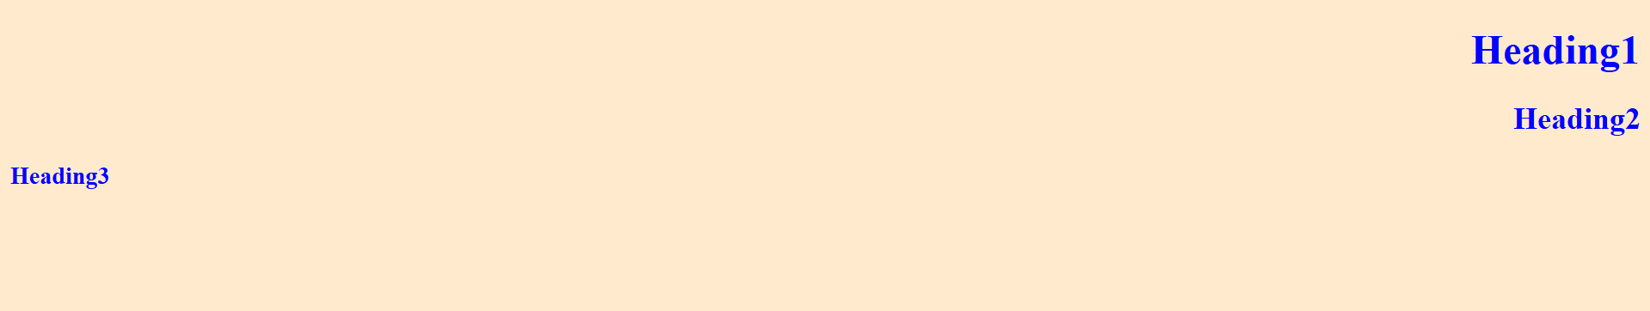
Applying id selector:
HTML file:
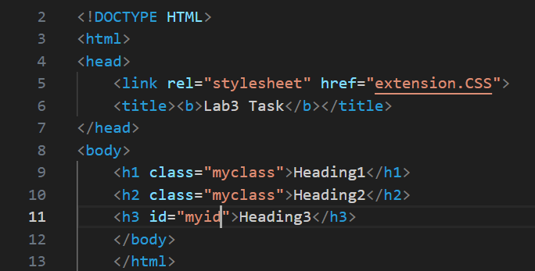
CSS File:
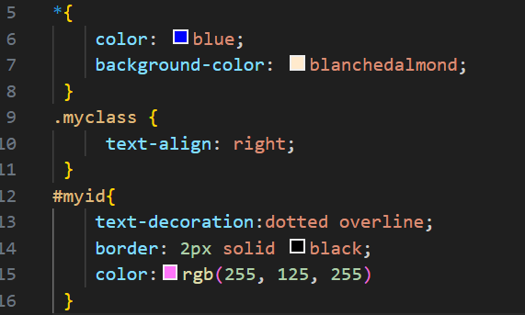
Code Changes Detail 🚀
The changes involve adding a unique ID attribute to the <h3> element and defining a powerful ID Selector rule in the External CSS.

- ID Added to <h3> Element:
  - The attribute id="myid" was added to the <h3>Heading3</h3> tag.
  - Detail: An id is a unique identifier, meaning only this one element on the page should use it.
- New External CSS Rule (ID Selector):
  - A new rule for the ID selector #myid was added to the external file (extension.CSS):
CSS
#myid {
text-decoration: dotted overline;
border: 2px solid black;
color: rgb(255, 125, 255);
}
  - Detail: The ID Selector (#myid) targets only the element with that specific ID (<h3>). This selector has the highest specificity among the tag, class, and ID selectors.
- Specific Effects on <h3>:
  - text-decoration: dotted overline;: Adds a dotted line above the text "Heading3".
  - border: 2px solid black;: Draws a 2-pixel solid black border around the <h3> element.
  - color: rgb(255, 125, 255): Sets the text color to a custom pink/magenta color, overriding the color: blue from the Universal Selector (*).
- Overall Result:
  - <h1> and <h2> remain blue, right-aligned, and have a blanchedalmond background.
  - <h3> receives a specific pink/magenta text color, a dotted overline, and a black border, while still retaining the blanchedalmond background from the Universal Selector.
Output:
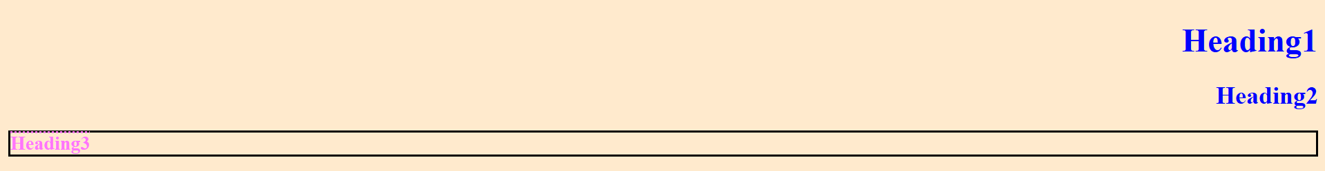
Applying id selector:
HTML file:
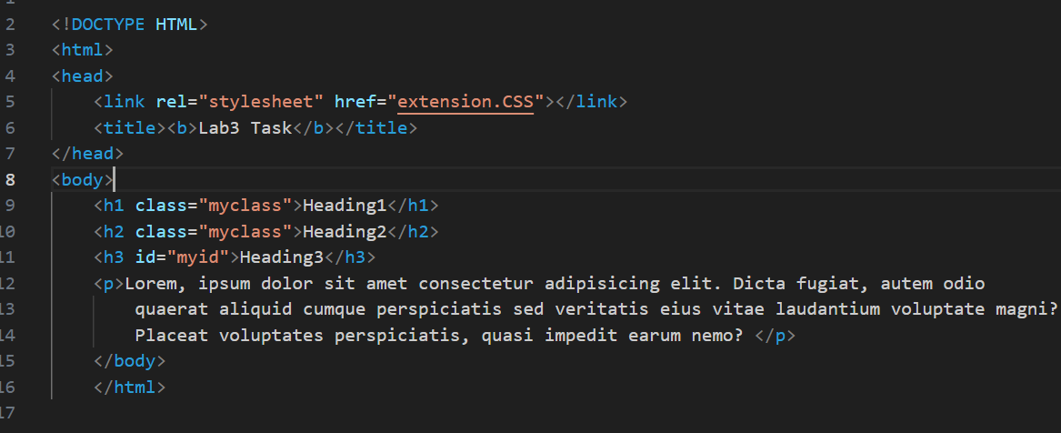
CSS File:
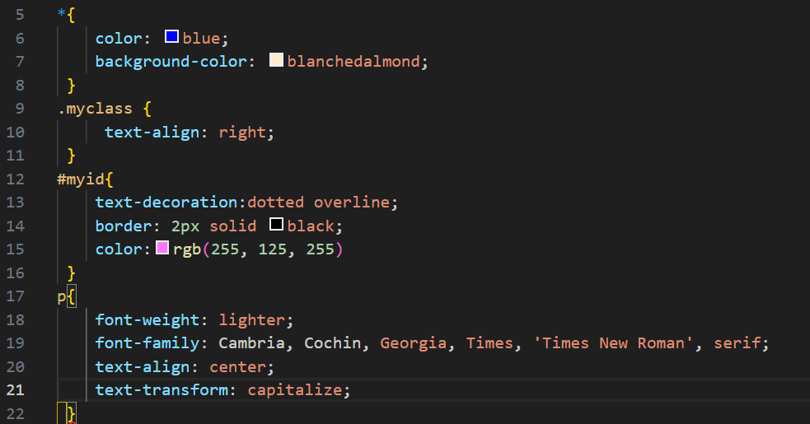
Code Changes Detail 📝
The changes involve the addition of a new paragraph element in the HTML and a corresponding new CSS rule using the Element Selector for paragraphs (p).

- New HTML Element Added:
  - A <p>...</p> tag containing a block of Lorem Ipsum placeholder text was added inside the <body> after the headings.
- New External CSS Rule (Element Selector):
  - A new rule targeting all paragraph elements (p) was added to the external file (extension.CSS):
CSS
p {
font-weight: lighter;
font-family: Cambria, Cochin, Georgia, Times, 'Times New Roman', serif;
text-align: center;
text-transform: capitalize;
}
- Specific Effects on the Paragraph (<p>):
  - The paragraph text will be styled:
    - Color & Background: It inherits color: blue and background-color: blanchedalmond from the Universal Selector (*).
    - font-weight: lighter;: Makes the text thinner than normal.
    - font-family: ...: Sets a specific font stack, starting with Cambria.
    - text-align: center;: Centers the paragraph text horizontally.
    - text-transform: capitalize;: Makes the first letter of every word in the paragraph uppercase.
- Output:
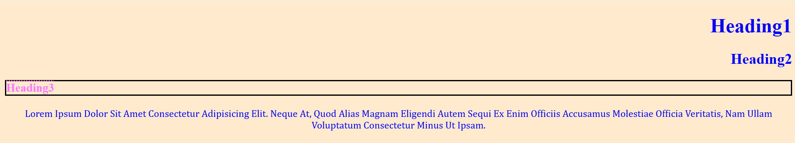
Final HTML file:


Final CSS file:
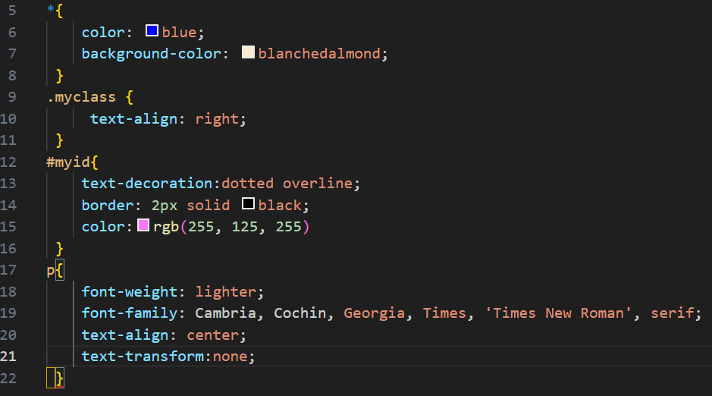
CSS Rule Change Detail 📝
The only change in the CSS rule for the paragraph element (p) is modifying the text capitalization property.

- text-transform Property Modified:
  - Original Value: text-transform: capitalize;
  - New Value: text-transform: none;
  - Effect: The previous rule automatically made the first letter of every word in the paragraph uppercase. Changing it to none removes this effect. The paragraph text will now display exactly as it is written in the HTML (likely all lowercase or mixed case.
The rest of the paragraph styles (font-weight, font-family, and text-align) remain the same.
Final output:
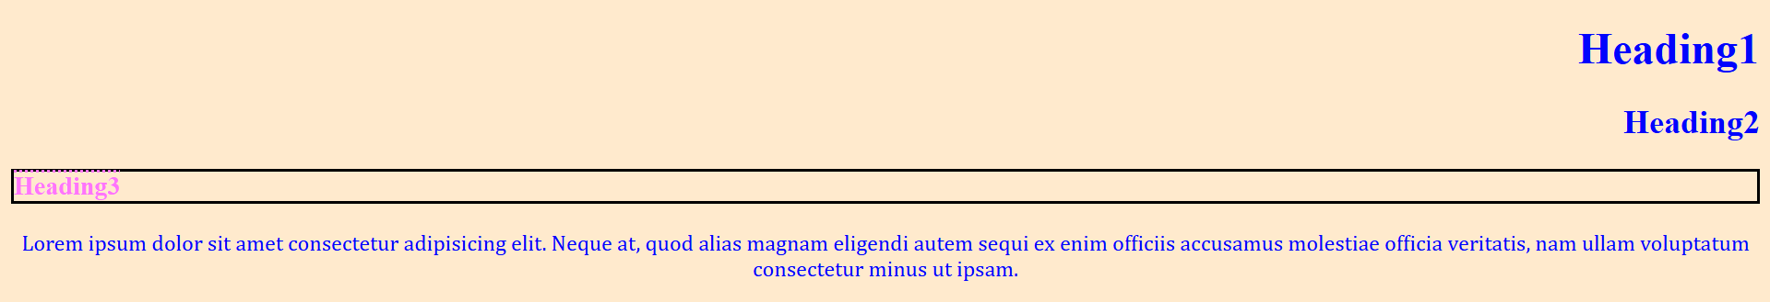
Task#3
- Q3: Create a button & set its background color to:
- Green using external css
- Blue using internal css
- Pink using inline css
HTML code:
Applying inline CSS on button:
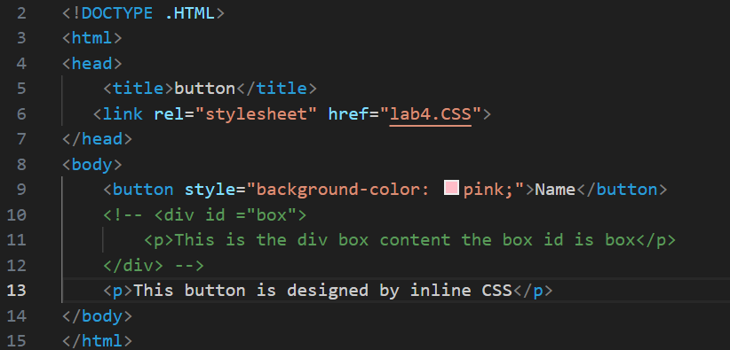
Code Detail 📝
The code involve the implementation of inline CSS on button tag .style=” background-color:pink will change the color of button to pink.
Output:
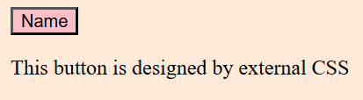
HTML code:
Applying internal CSS on button:

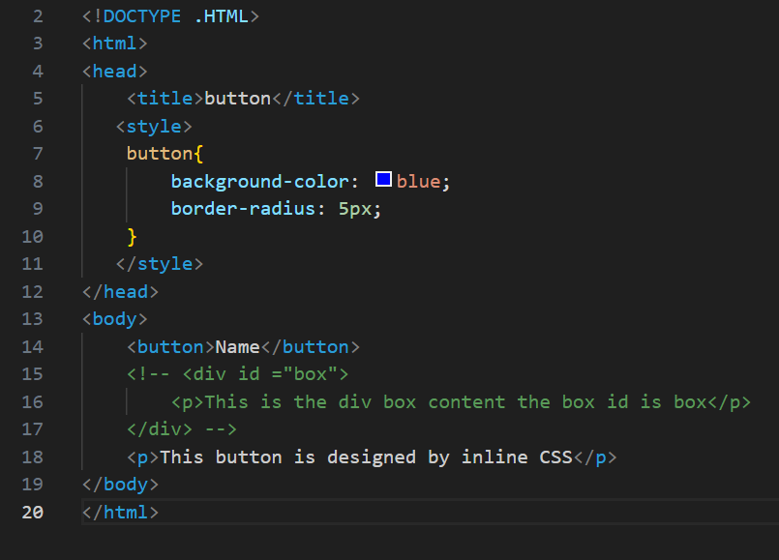
Code Detail 📝
The code involve the implementation of internal CSS on button tag.
<style> tag contains the button tag CSS the background-color will of button will change to blue and also it will have border curve of 5px.
Output:
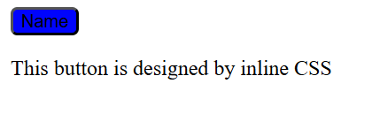
HTML code:
Applying External CSS on button:
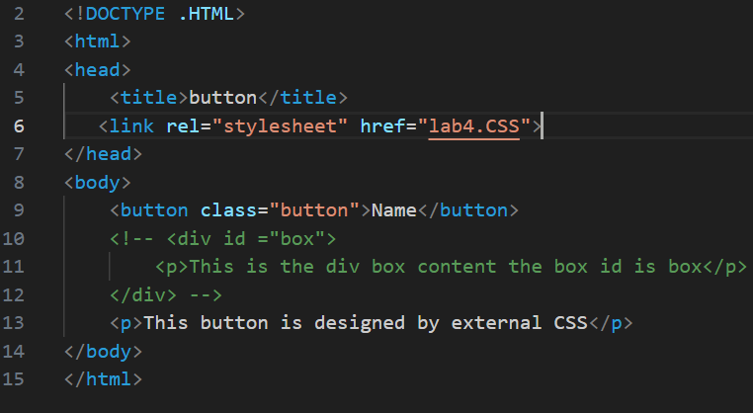
CSS code:
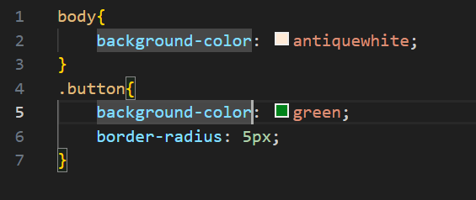
Code Detail 📝
The code involve the implementation of external CSS on button tag .There is a link of the CSS sheet in HTML file and also a class named button is defined in button tag . In CSS sheet there is background color that is set to antiquewhite and .button is the class created in HTML the background color of button change to green and border radius set to 5px.
Output:
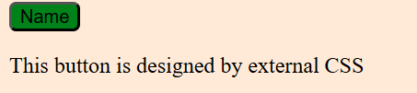
Task#4
- Q4: Create a div with height & width of 100px. Set its background color to green & the border radius to 50%
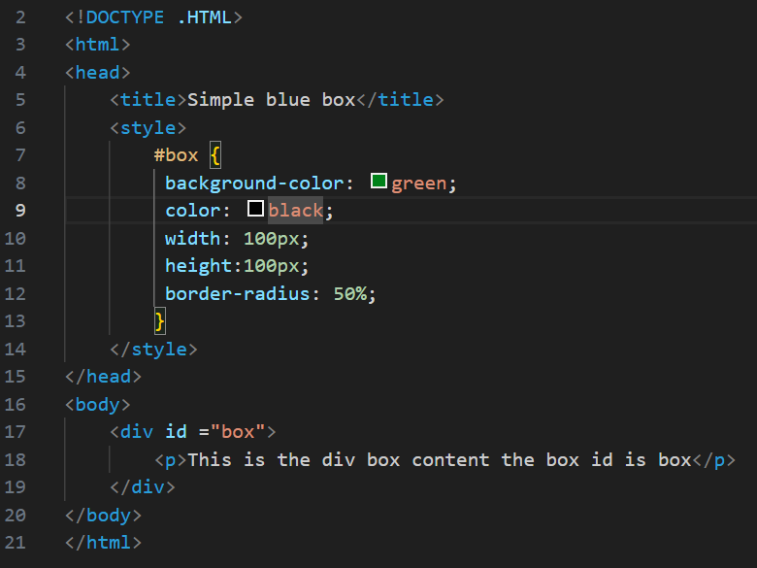
Code detail:
This code creates a webpage featuring a perfect green circle containing text, styled using CSS properties that transform the standard rectangular div element.

🎨 Internal CSS Styling (<style>)
The styles are defined inside the <head> section, targeting the element with the ID "box":
- #box Selector: This ID selector targets the div element with the ID "box".
  - background-color: green;: Sets the background color of the shape to green.
  - color: black;: Sets the text color inside the shape to black.
  - width: 100px;: Sets the width of the content area to 100 pixels.
  - height: 100px;: Sets the height of the content area to 100 pixels. Since the width and height are equal, this creates a square box before the next property is applied.
  - border-radius: 50%;: This is the key styling change. By setting the border radius to 50%, the CSS rounds all four corners completely, transforming the 100x100 pixel square into a perfect circle.
📄 HTML Structure (<body>)
The visible content section defines the styled element:
- <div id ="box">...</div>: The Division element is defined with the ID box, applying all the custom styles.
- <p>...</p>: A paragraph element containing the text "This is the div box content the box id is box" is nested inside the div. Due to the small size of the 100x100px circle, this text will likely overflow the boundaries of the circular shape.
Output:
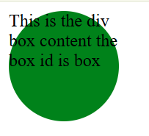
Lab#05
Task#1
Q1: Create attractive navigation bar using HTML and CSS.
Code:
HTML Code:
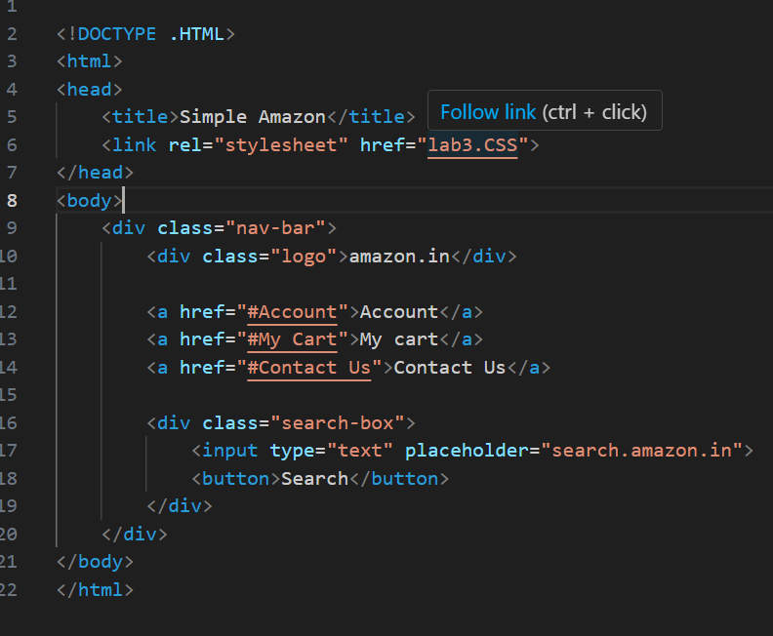
CSS Code:
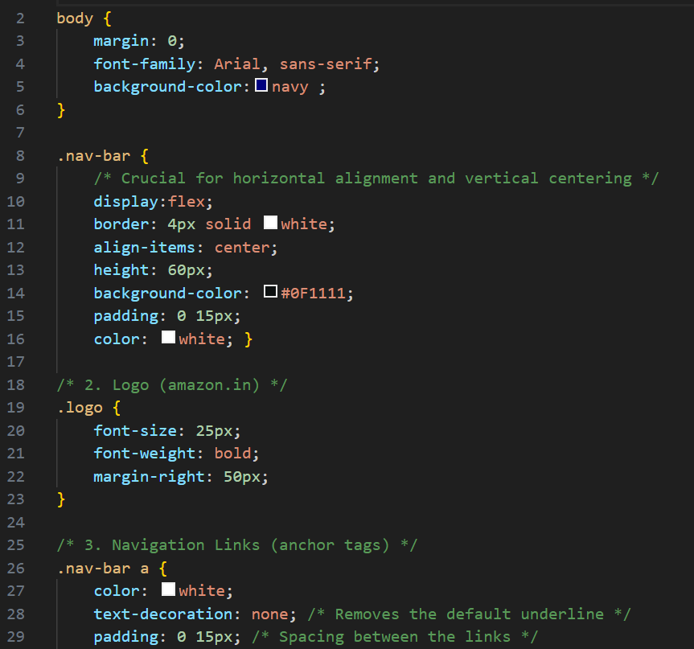
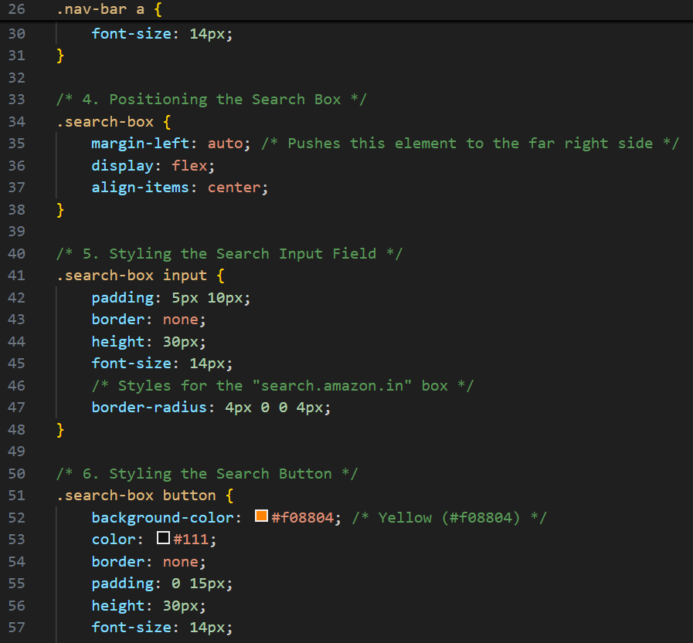
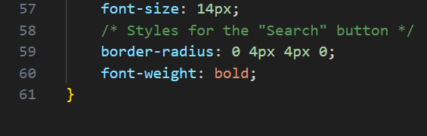
Code Detail:
This code creates a simulation of a basic Amazon navigation bar using HTML for structure and External CSS for layout.

💻 HTML Structure Detail
The HTML defines a simple page with a navigation bar containing a logo, navigation links, and a search input area.
- <link rel="stylesheet" href="lab3.CSS">: This line in the <head> links the HTML document to an External Stylesheet named lab3.CSS, where all the design rules are located.
- <div class="nav-bar">: This main container holds all the elements of the navigation bar. It's the key element that the CSS targets to enable the Flexbox layout.
  - <div class="logo">amazon.in</div>: Contains the site name.
  - <a href="...">...</a>: Three standard anchor tags (<a>) create the navigation links (Account, My cart, Contact Us).
  - <div class="search-box">: A nested container for the search elements.
    - <input type="text" ...>: The text field where a user types their search query.
    - <button>Search</button>: The button element to submit the search.

🎨 External CSS Styling Detail (lab3.CSS)
1. Body Styles
- body:
  - margin: 0;: Removes default browser margins.
  - font-family: Arial, sans-serif;: Sets a clean, standard font.
  - background-color: navy;: Sets the background color of the main page content area.
2. Navigation Bar Container (.nav-bar)
- display: flex;: Crucial—enables the Flexbox layout, allowing items to be arranged horizontally.
- align-items: center;: Vertically centers all items within the navigation bar.
- height: 60px;: Sets a fixed height for the bar.
- background-color: #0F1111;: Sets the background to a dark Amazon-like color.
- color: white;: Sets the default text color for elements in the bar (like the logo and links) to white.
- border: 4px solid white;: Adds a white border around the entire bar.
3. Logo Styling (.logo)
- font-size: 25px; and font-weight: bold;: Makes the logo text prominent.
- margin-right: 50px;: Creates space between the logo and the subsequent navigation links.
4. Link Styling (.nav-bar a)
- text-decoration: none;: Removes the default underline from the hyperlinks.
- padding: 0 15px;: Adds horizontal padding to create spacing between the links.
5. Search Box Positioning (.search-box)
- margin-left: auto;: This property is key; in a Flex container, margin-left: auto pushes the element (the search box) all the way to the right side, separating it from the links.
- display: flex;: Makes the search box container itself a Flex container to keep the input and button side-by-side.
6. Input and Button Styling
- .search-box input:
  - border-radius: 4px 0 0 4px;: Rounds only the left corners (top-left, bottom-left) of the input field, allowing it to merge visually with the button on the right.
- .search-box button:
  - background-color: #f08804;: Sets the background to the distinctive Amazon orange.
  - border-radius: 0 4px 4px 0;: Rounds only the right corners (top-right, bottom-right) of the button, making it merge visually with the input field on the left.
  - font-weight: bold;: Makes the "Search" text stand out.
Output:
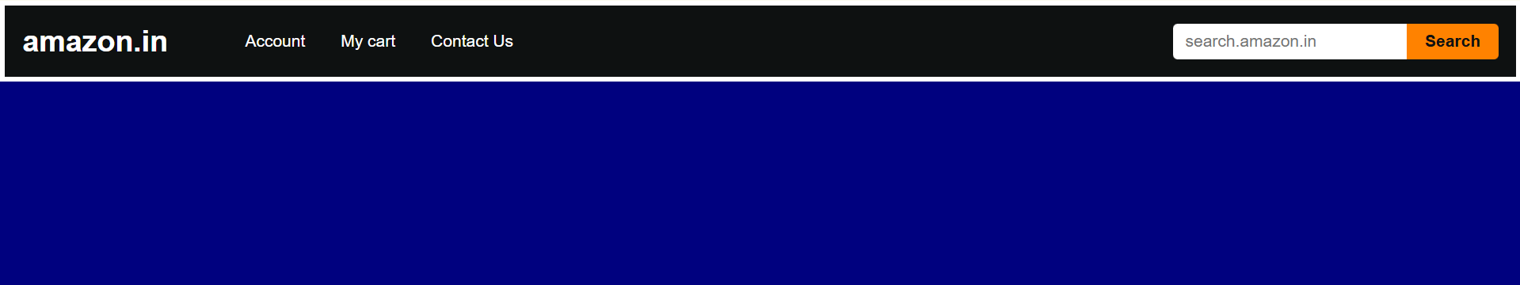
Task#2
- Q2: Create webpage layout as given in picture below:
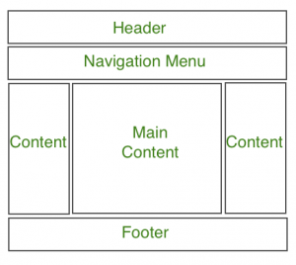
HTML Code:
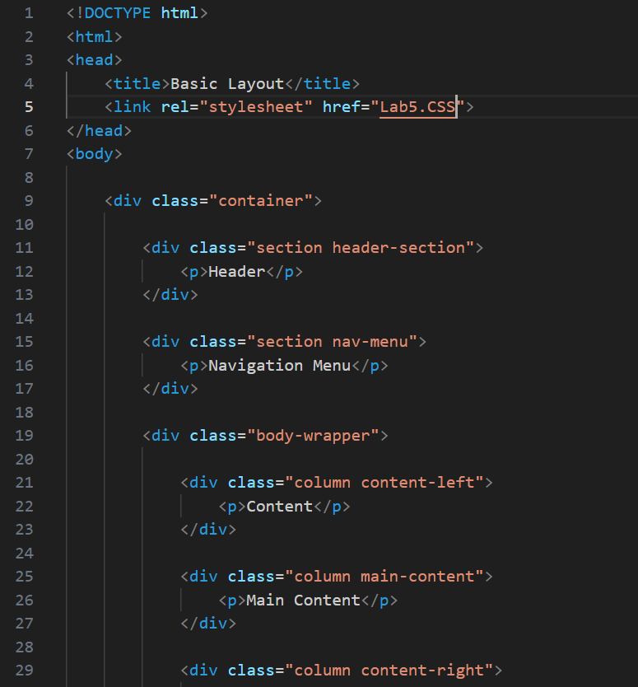
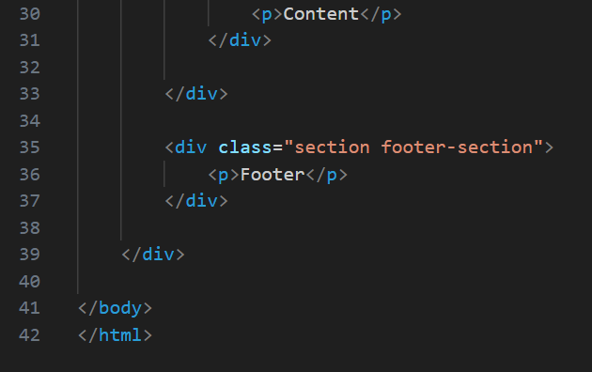
CSS Code:
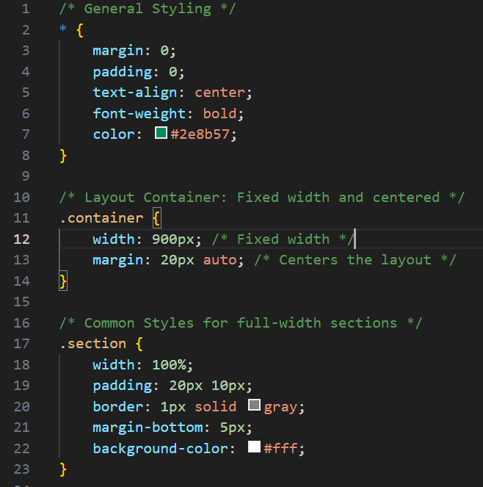
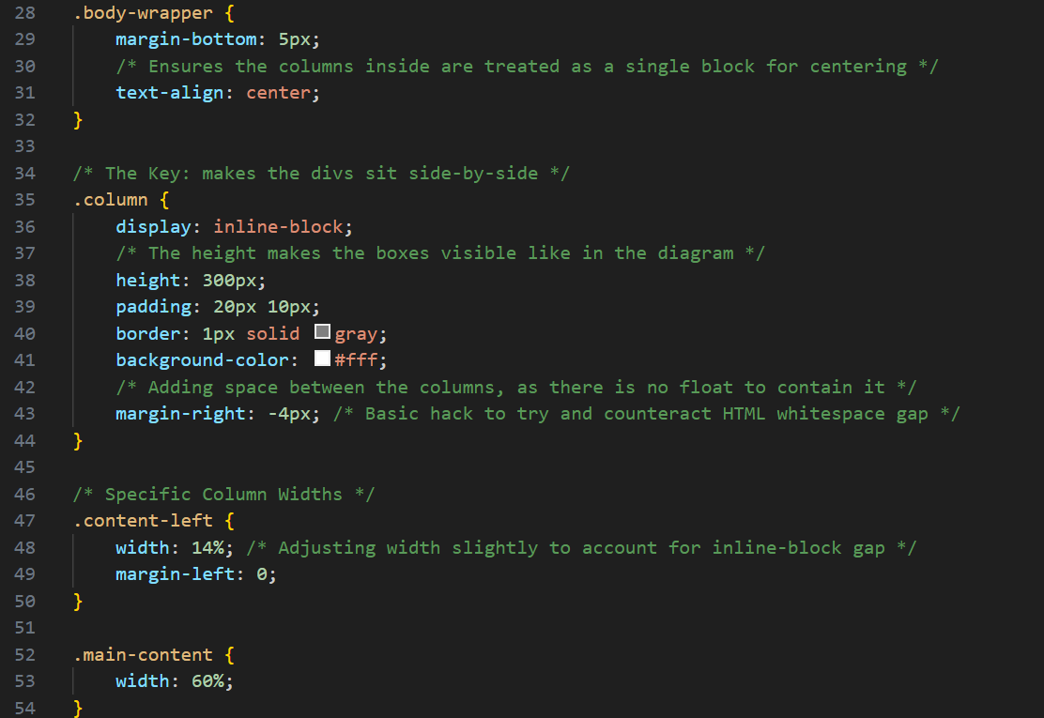
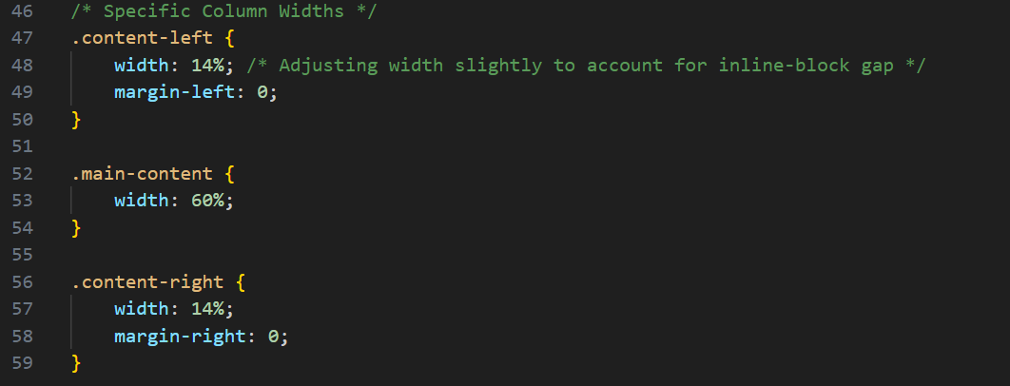
Code detail:
This code creates a fixed-width, centered five-section webpage layout (Header, Nav, three columns, Footer) using an older layout technique: display: inline-block for the columns.

💻 HTML Structure Detail
The structure defines a hierarchy of nested containers for the layout:
- <div class="container">: The root element holding all page content, designed to be centered on the screen.
- Full-Width Sections (.section):
  - header-section, nav-menu, and footer-section are divs that will span the full width of the container.
- Column Wrapper (.body-wrapper):
  - This element wraps the three columns and is crucial for styling the inline-block layout method.
- Content Columns (.column):
  - content-left, main-content, and content-right are the three individual divs designed to sit horizontally.

🎨 CSS Styling Detail
The styling is applied via an External Stylesheet (Lab5.CSS) and uses specific techniques to manage the layout.
1. General & Layout Container
Selector | Property | Description
* (Universal) | margin: 0; padding: 0; | CSS Reset: Removes default browser margin and padding.
 | color: #2e8b57; font-weight: bold; | Sets the default text color to dark seagreen and makes all text bold.
.container | width: 900px; | Sets the entire page content area to a fixed width of 900 pixels.
 | margin: 20px auto; | Centers the entire 900px layout horizontally within the browser window and adds 20px margin at the top/bottom.

2. Full-Width Sections
Selector | Property | Description
.section | width: 100%; padding: 20px 10px; | Ensures Header, Nav, and Footer span the full 900px width and adds internal padding.
 | border: 1px solid gray; margin-bottom: 5px; | Applies a visual gray border and vertical spacing below each section.

3. Three-Column Layout (The inline-block Method)
This is the most critical part, arranging the three columns horizontally.
Selector | Property | Function / Layout Technique
.body-wrapper | text-align: center; | Crucial: Because inline-block elements behave like text, this centers the entire block of columns horizontally.
.column | display: inline-block; | Key Property: Forces these elements to sit side-by-side instead of stacking vertically.
 | height: 300px; | Sets a fixed height for all columns for visual appearance.
 | margin-right: -4px; | A common hack used with inline-block to remove the whitespace gap (usually 3-5px) that browsers insert between the column elements due to line breaks in the HTML source.
Column Widths | width: 14%; 60%; 14%; | Dimensions: Allocates 14% for the sidebars, leaving 60% for the central content.

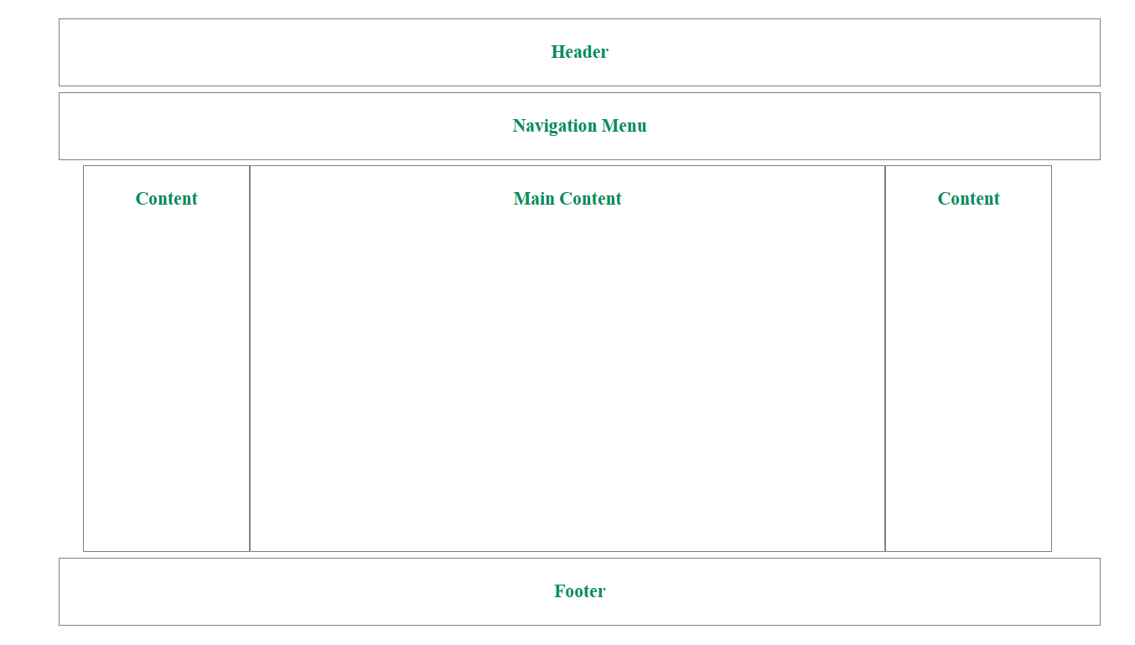
Task#3
- Q3: Add previous navbar as mentioned in Q1 in Navigation Menu section.
HTML Code:
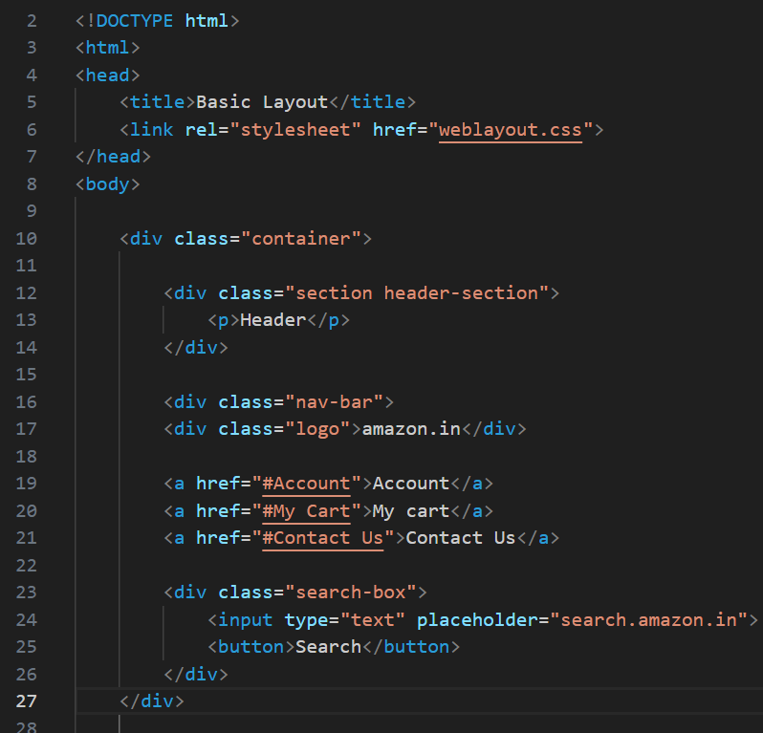
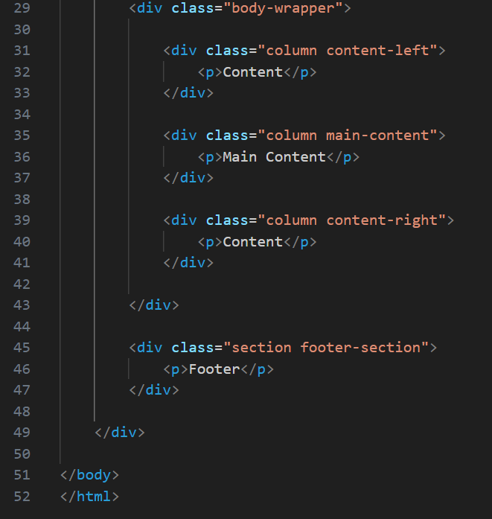

CSS Code:
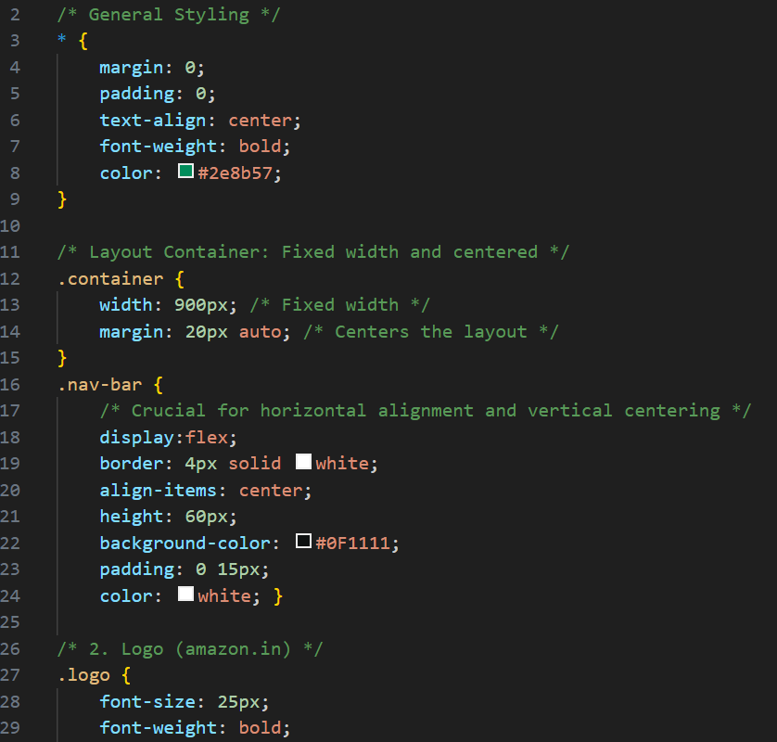
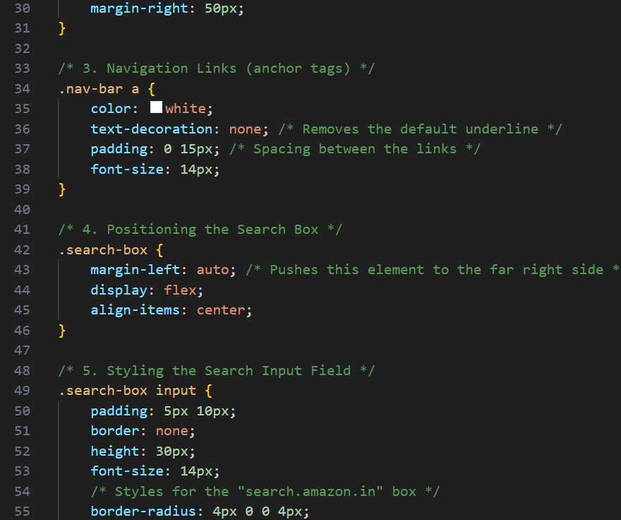
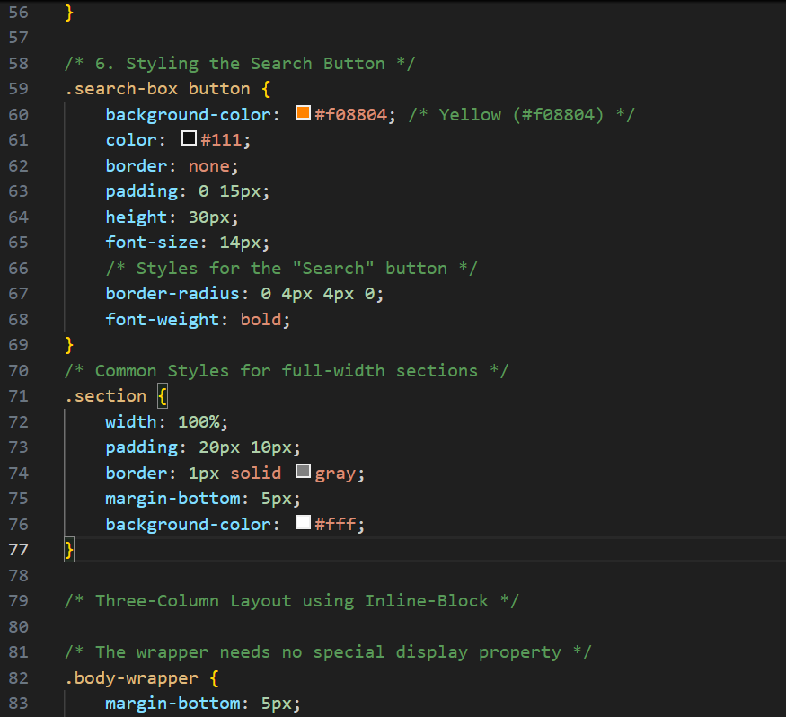
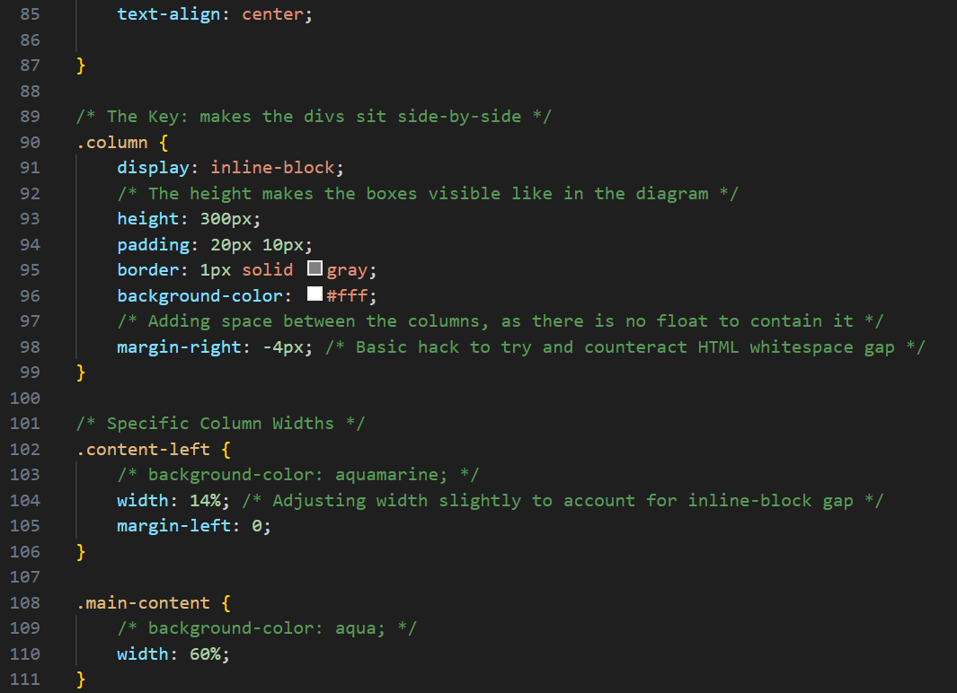
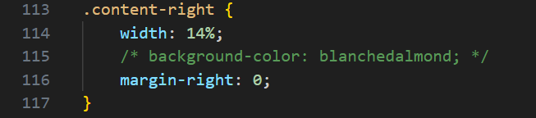
Code detail:
This code defines a fixed-width, centered webpage layout using a mix of modern and traditional CSS techniques. The main structure uses full-width blocks, while the central content area uses the display: inline-block method for its three columns. The navigation section is styled as a detailed Amazon-style navbar using Flexbox.

💻 HTML Structure Detail
The HTML defines the standard five-part structure, all nested within a main <div class="container">:
- Header/Footer/Full-Width: Uses the class="section" for the header-section and footer-section.
- Navigation: The entire Amazon Navbar structure (<div class="nav-bar">...</div>) is placed directly between the header and the main body wrapper. This nav-bar uses classes like .logo, .search-box, etc.
- Three-Column Wrapper: The <div class="body-wrapper"> contains the three content columns: .content-left, .main-content, and .content-right, all sharing the class="column".

🎨 CSS Styling Detail
The CSS applies a shared dark-seagreen text color and two distinct layout methods:
1. General & Layout Container
- * (Universal Selector): Sets a CSS Reset (margin: 0; padding: 0;) and defines global styles: bold text, centered text, and a default dark seagreen color (#2e8b57).
- .container: Sets the entire page content to a fixed width of 900px and uses margin: 20px auto; to center the layout horizontally on the screen.
- .section: Styles the Header and Footer to span 100% of the container's width, with a white background (#fff) and a gray border.
2. Amazon Navbar (.nav-bar)
This section uses Flexbox for horizontal arrangement:
- .nav-bar: Uses display: flex; to arrange its items in a row and align-items: center; to center them vertically within its 60px height. It has a dark background (#0F1111) and white text.
- .search-box: Uses margin-left: auto; to push the search component to the far right of the navbar.
- Input/Button: The search input and button are styled to visually merge together, with the button using the signature Amazon orange (#f08804).
3. Three-Column Content (.body-wrapper)
This section uses the older inline-block method for the column arrangement:
- .body-wrapper: text-align: center; is crucial here, as it centers the entire block of inline-block columns.
- .column: The display: inline-block; property is the key that makes the divs sit side-by-side.
  - height: 300px; sets a fixed height for all columns.
  - margin-right: -4px; is a common hack used to eliminate the small whitespace gap that browsers introduce between inline-block elements in the HTML source code.
- Widths: The columns are sized proportionally: 14% for the sidebars, and 60% for the main content ($14\% + 60\% + 14\% = 88\%$ total width).
Output:
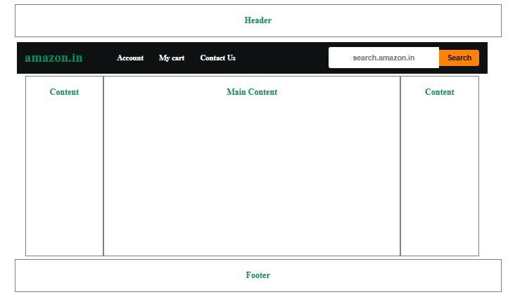
Task#4
- Q4: Add a different background color to each content section with an opacity of 0.5
HTML Code:


CSS Code:



Before opacity apply:
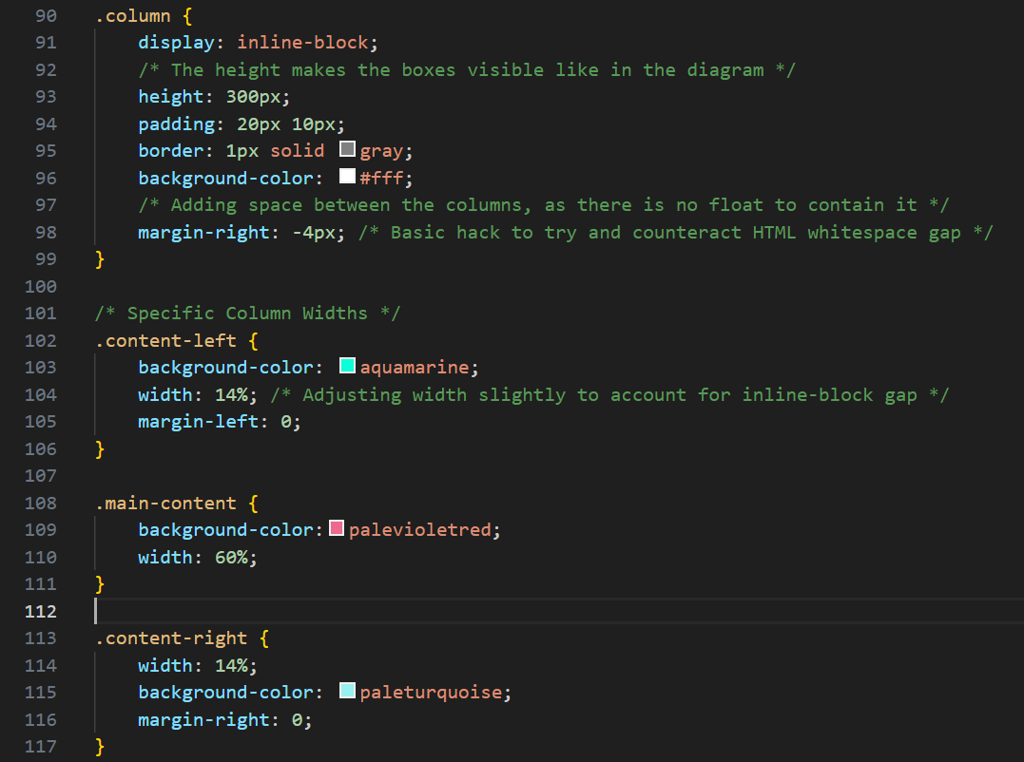
After opacity apply:
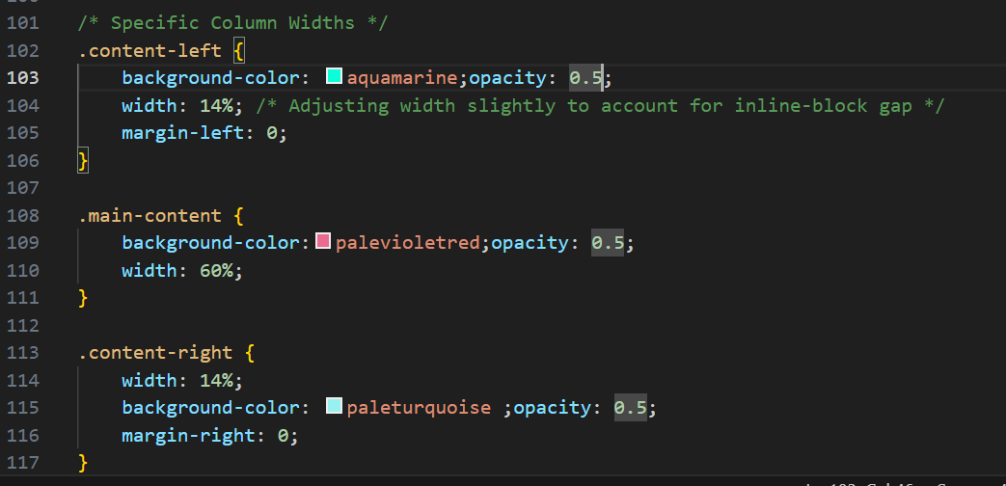
Code detail:
The primary changes in the CSS involve the addition of background-color and opacity properties to the three content columns (.content-left, .main-content, and .content-right).

💡 Opacity and Color Changes Detail
The focus of the change is to visually distinguish and make the three side-by-side columns semi-transparent.
Selector | Properties Added/Changed | New Value | Effect
.content-left | background-color | aquamarine; | Sets the background of the left sidebar to a light, vibrant blue-green.
 | opacity | 0.5; | Makes the left sidebar 50% transparent.
.main-content | background-color | palevioletred; | Sets the background of the main central column to a light red-pink.
 | opacity | 0.5; | Makes the main content area 50% transparent.
.content-right | background-color | paleturquoise; | Sets the background of the right sidebar to a light greenish-blue.
 | opacity | 0.5; | Makes the right sidebar 50% transparent.
Output:
Before opacity:
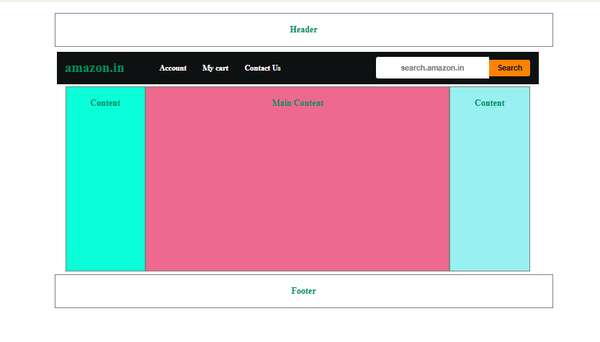
After opacity:

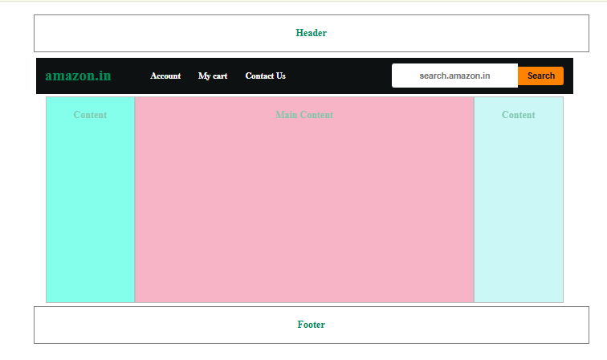
Lab#06
Media query& Transition Properties

- Q1. Add a media query to implement the following:
  - The color of a div changes to yellow for viewport width less than 200px
  - The color of a div changes to blue for width between 200px & 400px
  - The color of a div changes to red for width between 400px & 600px
  - The color of a div changes to green for width above 600px
HTML Code:
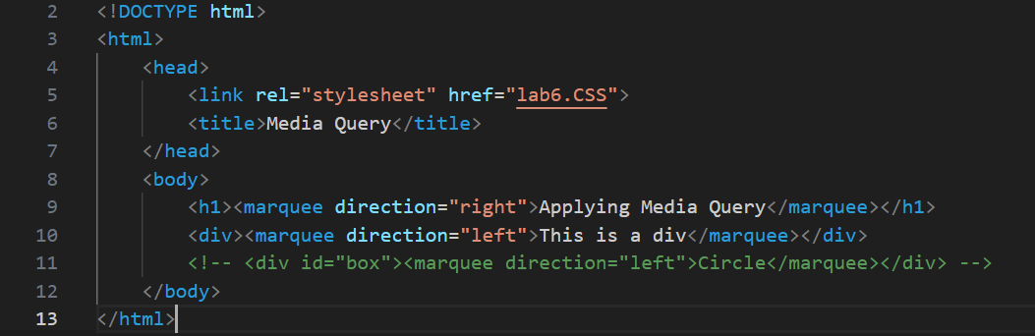
CSS Code:
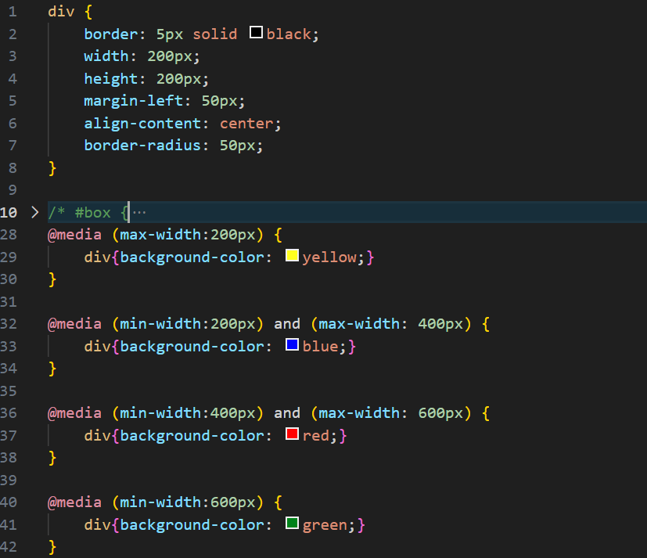
Code Detail:
This code demonstrates a basic implementation of Media Queries in CSS to make the styling of a <div> element responsive based on the browser's width.
💻 HTML Structure Detail
The HTML is very simple, consisting of a title, a heading, and a single <div> element.
- External CSS: It links to an external stylesheet named lab6.CSS where all the provided styles are defined.
- <h1> and <div>: Both the main heading and the content box use the non-standard and deprecated <marquee> tag to create continuously scrolling text. The <h1> scrolls right, and the <div> scrolls left.

🎨 CSS Styling Detail
The CSS includes base styling for all div elements and several Media Query blocks to change the background color based on screen size.
1. Base div Styling
The first block of CSS applies to all div elements unless overridden by a more specific rule (like a Media Query):
- border: 5px solid black;: Adds a 5-pixel black border.
- width: 200px; height: 200px;: Sets the div to a fixed 200x200 pixel size.
- margin-left: 50px;: Pushes the box 50 pixels from the left edge.
- border-radius: 50px;: Rounds the corners of the box.
2. Media Queries (Responsiveness)
The @media rules are the core of this example. They check the browser width and apply a new background color to the div element accordingly :
Media Query | Condition | Effect Applied to div
@media (max-width: 200px) | Screen width is 0px up to 200px. | Background color: yellow
@media (min-width: 200px) and (max-width: 400px) | Screen width is 200px up to 400px. | Background color: blue
@media (min-width: 400px) and (max-width: 600px) | Screen width is 400px up to 600px. | Background color: red
@media (min-width: 600px) | Screen width is 600px and wider. | Background color: green
Function: As the user resizes the browser window, the div box will dynamically change its background color to signal which range of screen width the application is currently using.
Output:

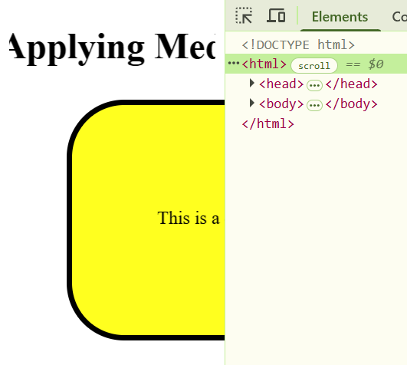
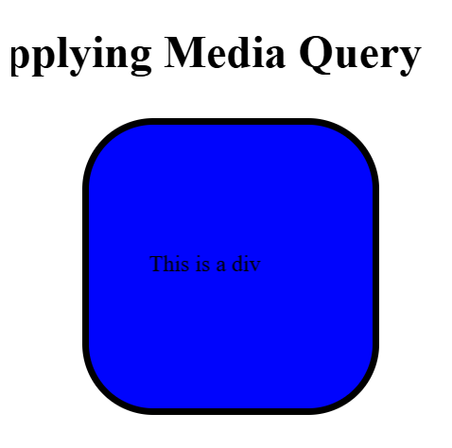
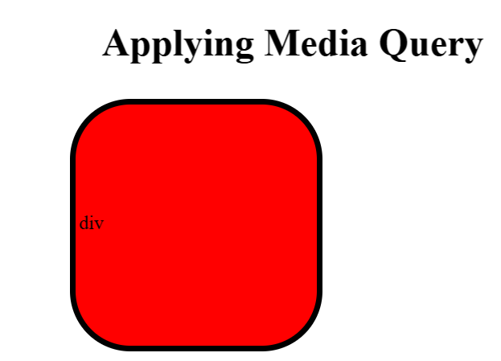
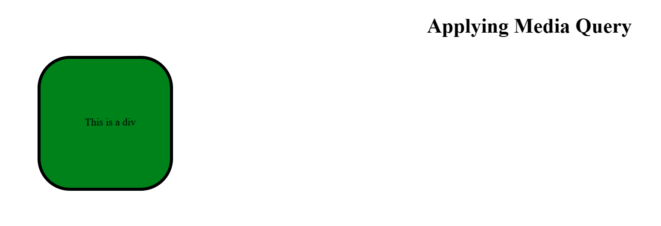
- Q2. Create a simple loader using CSS
  - Step 1: create a div with circular shape & a thick border from top with one color and remaining sides with different color.
  - Step 2: To make it spin create an animation which transforms it from 0deg to 360deg
  - Step 3: Add the animation property to the loader with infinite duration
HTML Code:
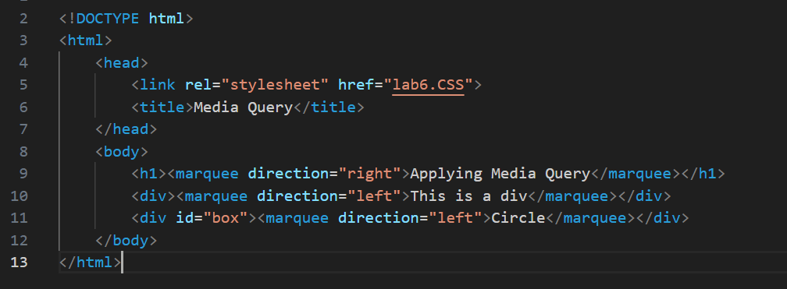
CSS Code:
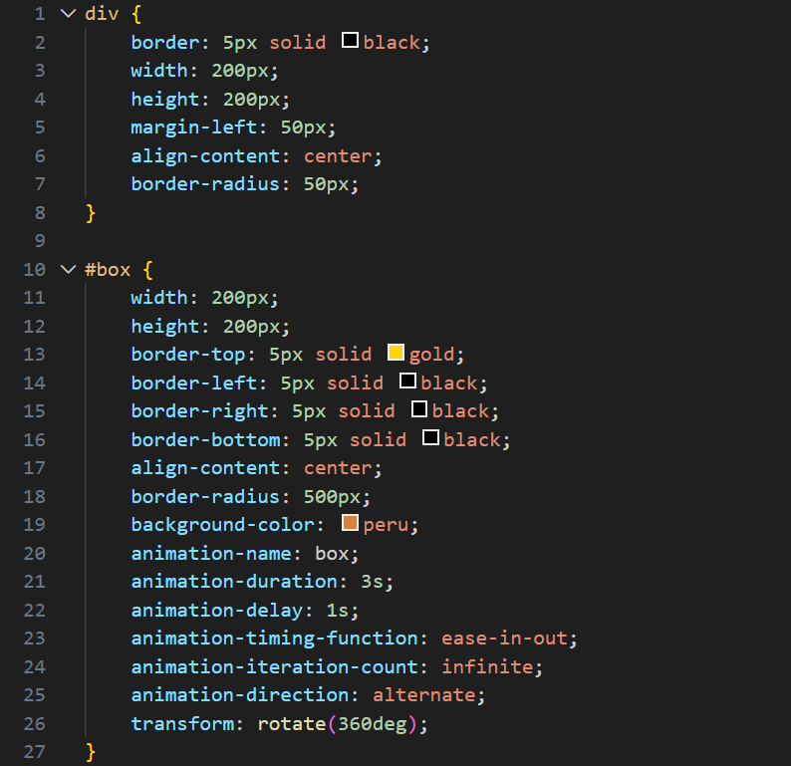
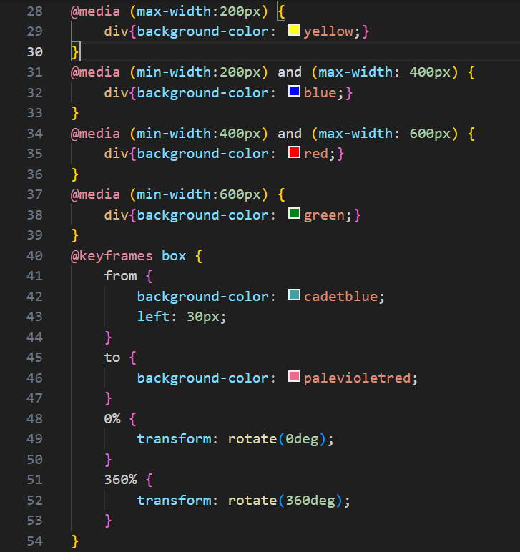
HTML code Detail:
The HTML file now contain another div with id named box. Also there is marquee implementation in left direction on text “Circle”.
🎨 Active CSS Styling Detail
The CSS now applies two distinct sets of styles to the two div elements, with the Media Queries controlling the background color of the basic div selector.
1. Base div Styling (Applies to the first <div>)
The rules targeting the generic div element apply to the first <div> in the HTML (<div><marquee>...</div>), as the second one has a more specific ID (#box).
- Size & Shape: Fixed at 200px by 200px with a 5px solid black border.
- Corners: border-radius: 50px; creates rounded corners.
- Position: margin-left: 50px; offsets the box from the left margin.
2. #box Styling (Applies to the second <div>)
The #box selector is more specific and overrides the base div styles. This creates a visually complex, animated circular shape.
- Size & Shape: Fixed at 200px by 200px.
  - Borders: Uses different border colors (gold top, black others).
  - Circular Shape: border-radius: 500px; forces the 200x200px box into a perfect circle.
- Animation (Active):
  - background-color: peru; is the initial background color.
  - It is linked to the @keyframes box rule: it runs infinitely (infinite) for 3 seconds (3s) in an alternating direction (alternate), starting after a 1-second delay (1s).
  - The static transform: rotate(360deg); is also applied.
3. @keyframes box Detail
The animation gradually changes the styling of the #box over its 3-second duration:
- Start (from): The animation begins with the background color cadetblue and sets the element's horizontal position (left: 30px).
- End (to): The animation ends with the background color palevioletred.
- Rotation: The 0% to 360% rotation keyframes are defined to make the box spin during the animation cycle.

📱 Media Queries (Responsiveness)
The Media Queries exclusively target the generic div selector (affecting only the first box) and change its background color based on the browser window width:
Condition (Browser Width) | Background Color Applied to First <div>
max-width: 200px | yellow 🟡
min-width: 200px and max-width: 400px | blue 🔵
min-width: 400px and max-width: 600px | red 🔴
min-width: 600px | green 🟢
Function: The first box dynamically changes color as the screen is resized, demonstrating basic responsive design, while the second box (#box) remains styled and animated consistently across all screen sizes.
Output:
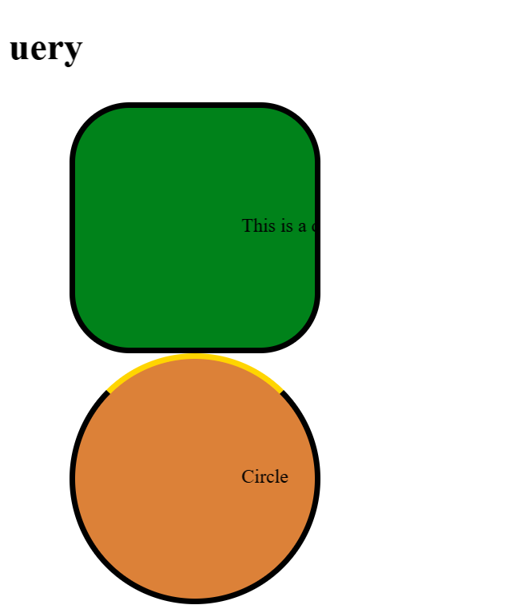
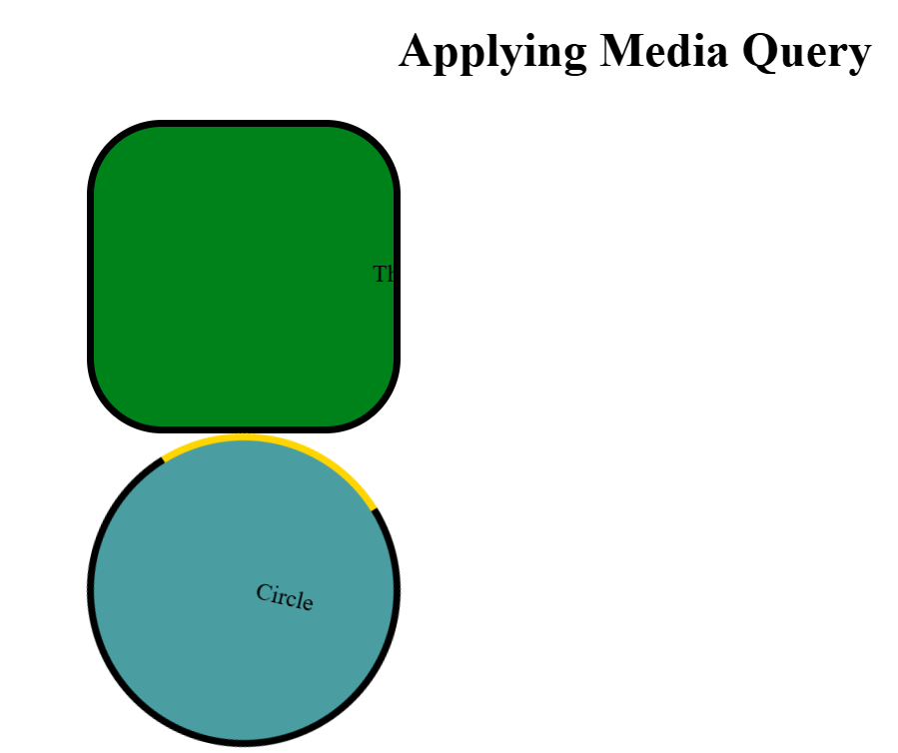
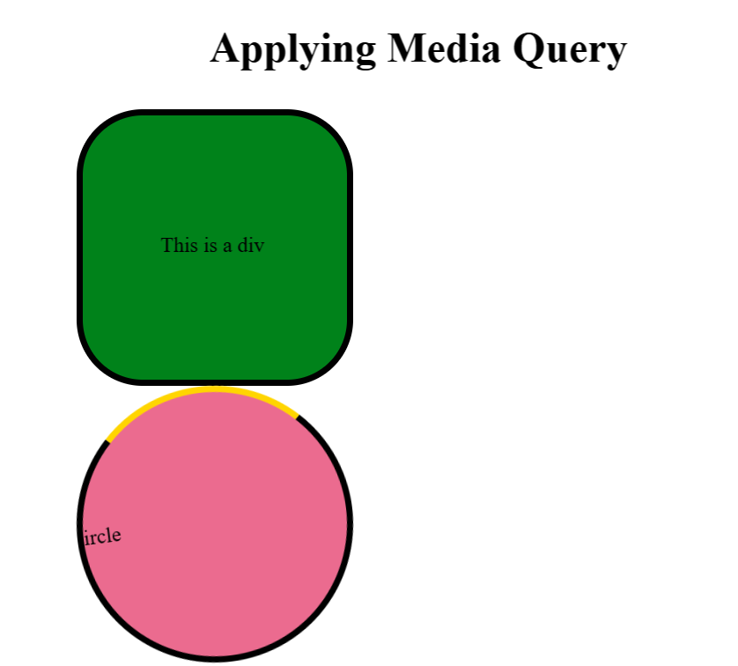

Lab#07
CV
HTML Code:
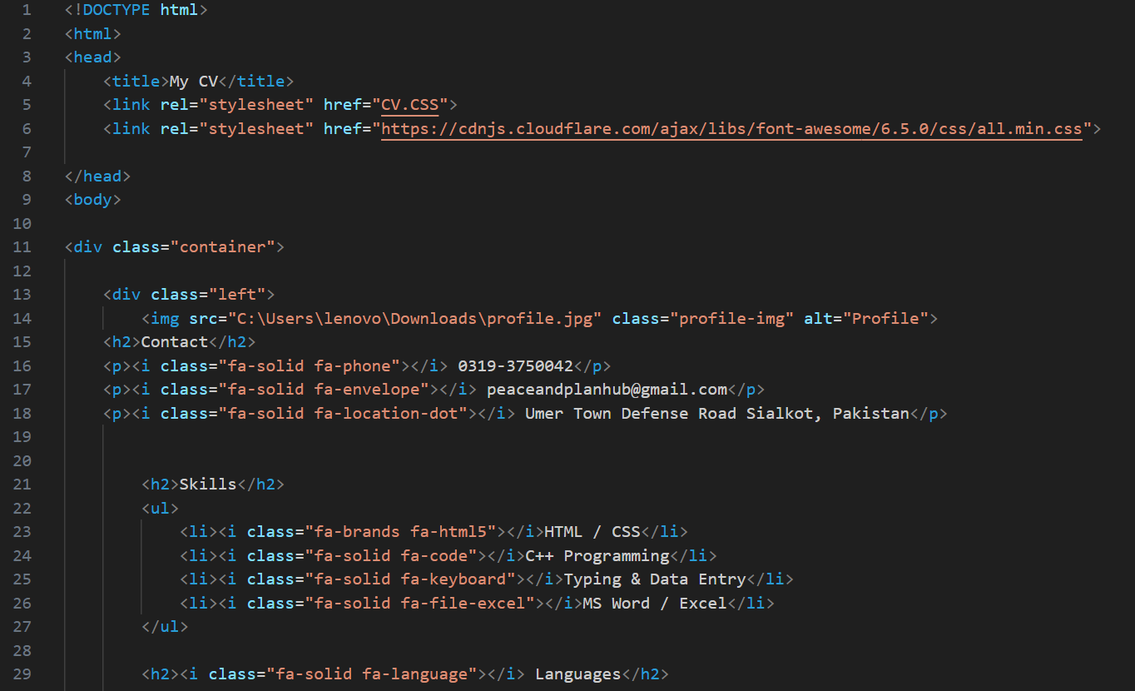
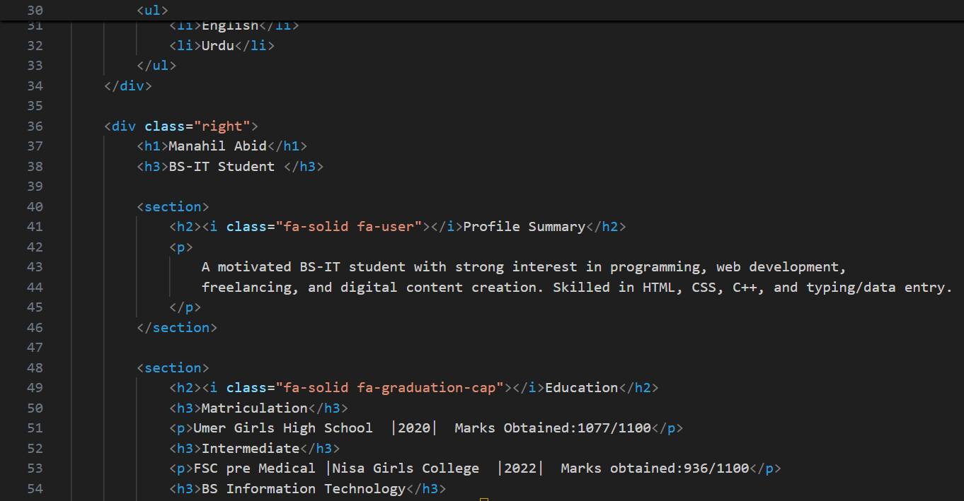
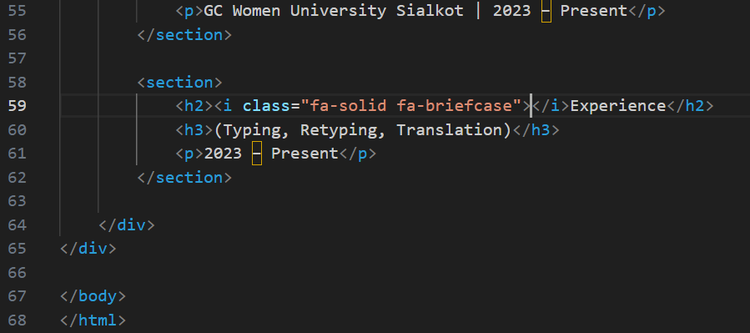
CSS Code:
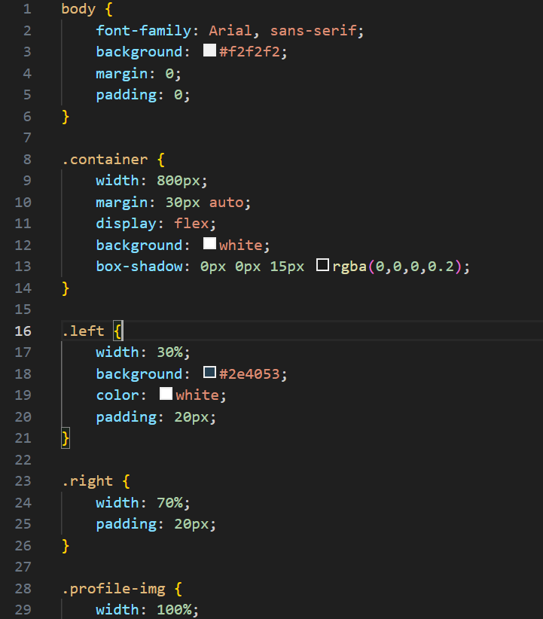
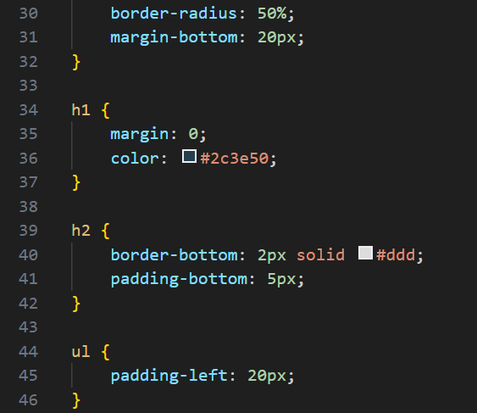
Code Detail:
This code creates a two-column resume (CV) layout using HTML5 for structure and Flexbox in the CSS for the horizontal arrangement. It separates personal information and skills (left column) from professional details (right column).

💻 HTML Structure Detail
The entire document is built around a main wrapper and two primary columns:
- External Resources:
  - <link rel="stylesheet" href="CV.CSS">: Links to the external CSS file for all styling.
  - <link rel="stylesheet" href="https://cdnjs.cloudflare.com/ajax/libs/font-awesome/6.5.0/css/all.min.css">: Links to the Font Awesome library to enable the use of icons (like phone, envelope, location pin).
- <div class="container">: The main wrapper for the entire CV content, which the CSS uses as the Flex Container.
1. Left Column (.left) - Sidebar
This column is intended for quick reference information:
- Image: An <img> tag attempts to load a profile picture from a local file path. It is given the class .profile-img.
- Contact Information: Uses <p> tags with Font Awesome icons (<i> tags with classes like fa-solid fa-phone) to display the phone number, email, and address.
- Skills & Languages(with Font Awesome icon): Structured using headings (<h2>) and unordered lists (<ul>) for easy readability.
2. Right Column (.right) - Main Content
This column holds the detailed professional history and summary:
- Name & Title: Uses <h1> and <h3> for the candidate's name and current student status.
- Sections: Uses <section> elements to logically group content:
  - Profile Summary(with Font Awesome icon): A short introductory paragraph.
  - Education (with Font Awesome icon): Details degrees/qualifications using <h3> for titles and <p> for dates/marks.
  - Experience (with Font Awesome icon): Details work history or relevant experience.

🎨 CSS Styling Detail
The CSS enforces a clean, fixed-width, two-column structure using Flexbox.
1. General & Layout Container
Selector | Property | Description
body | background: #f2f2f2; | Sets a light gray background for the area outside the CV container.
.container | width: 800px; | Sets the CV to a fixed width of 800 pixels.
 | margin: 30px auto; | Centers the CV horizontally on the page.
 | display: flex; | Key Layout Rule: Establishes this as a Flex container, forcing the .left and .right columns to sit side-by-side.
 | background: white; box-shadow: ... | Gives the CV a white background and a subtle shadow, making it look like a physical document floating on the page.
2. Column Sizing and Styling
Selector | Property | Description
.left (Sidebar) | width: 30%; | The sidebar takes 30% of the 800px width.
 | background: #2e4053; color: white; | Sets a dark, professional blue background and white text for high contrast.
.right (Main) | width: 70%; | The main content area takes 70% of the 800px width.
 | padding: 20px; | Both columns use padding to add internal spacing.
3. Element Styling
- .profile-img:
  - width: 100%; makes the image span the full width of the 30% left column.
  - border-radius: 50%; crops the image into a perfect circle.
- h2: Creates a subtle separator line below section headings using border-bottom.
Output:
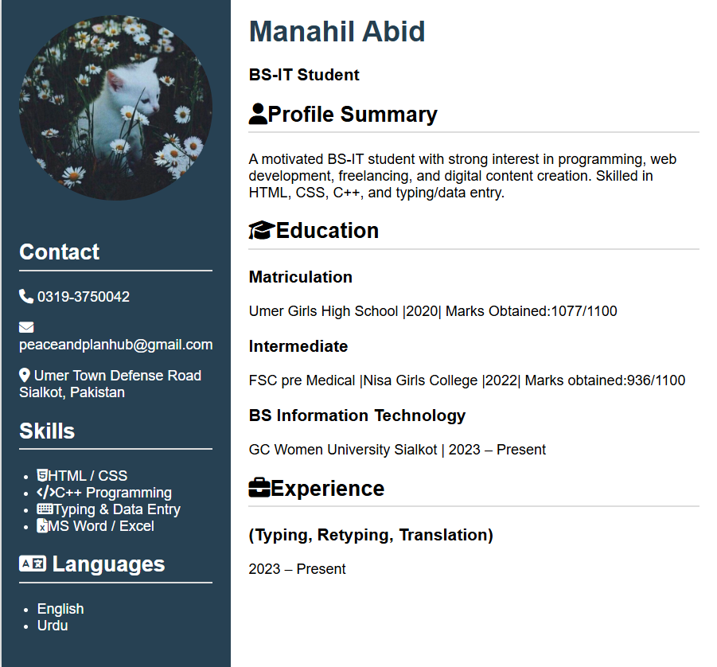
Lab#08
Portfolio
HTML Code:

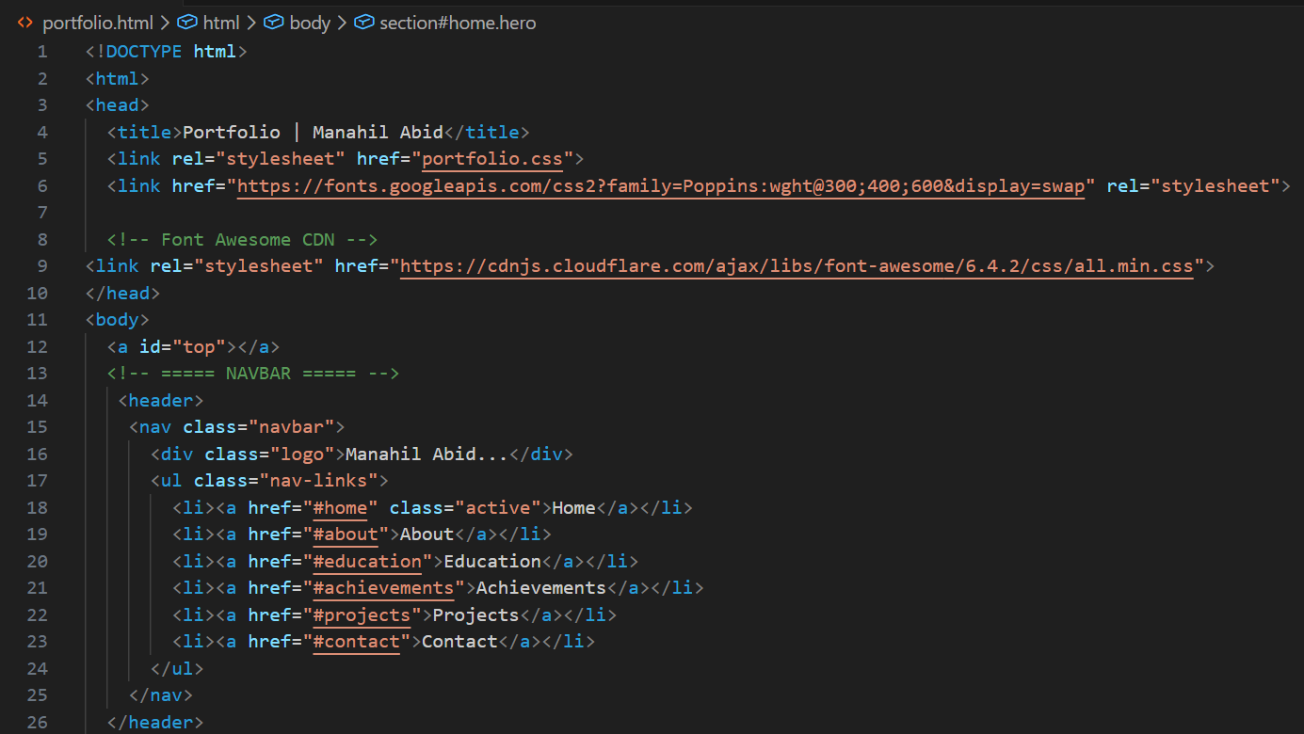
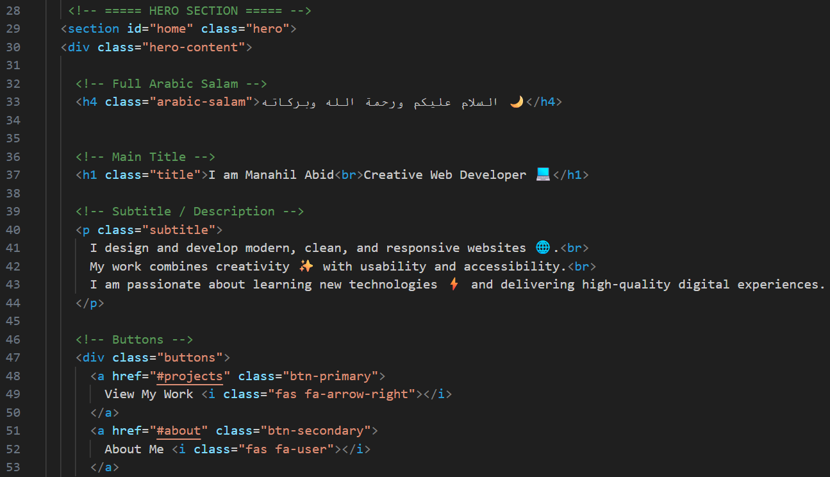
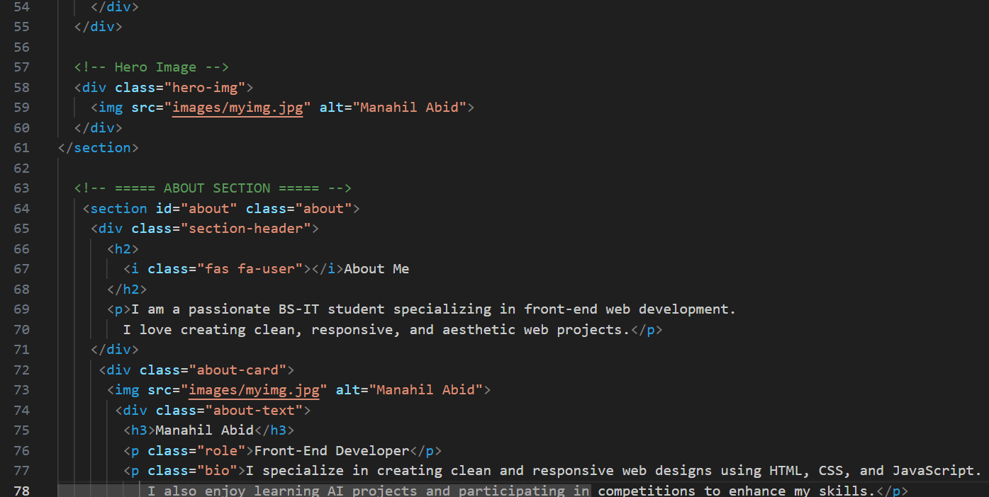
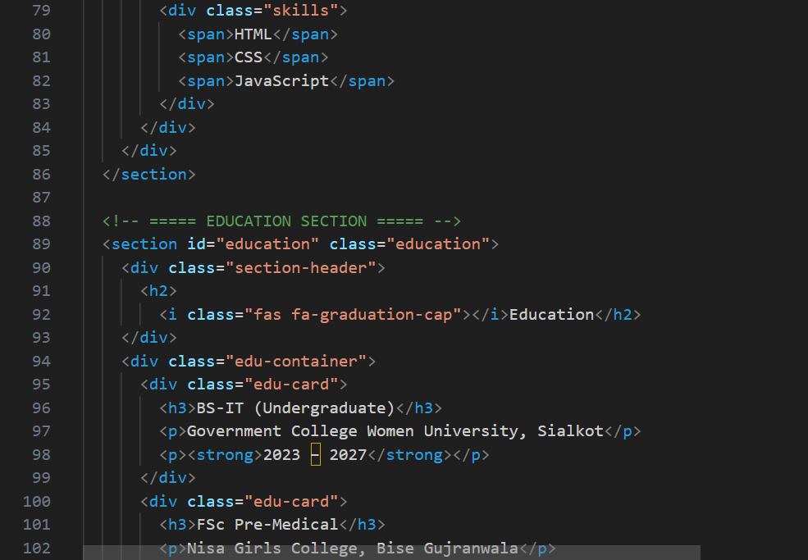
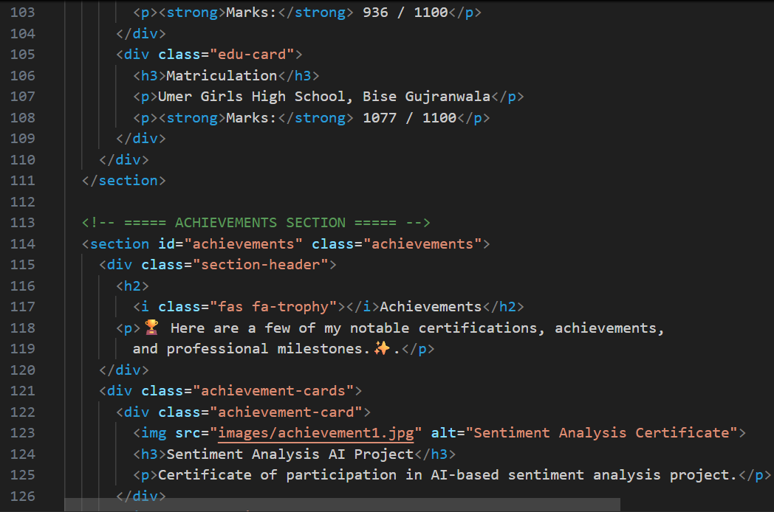
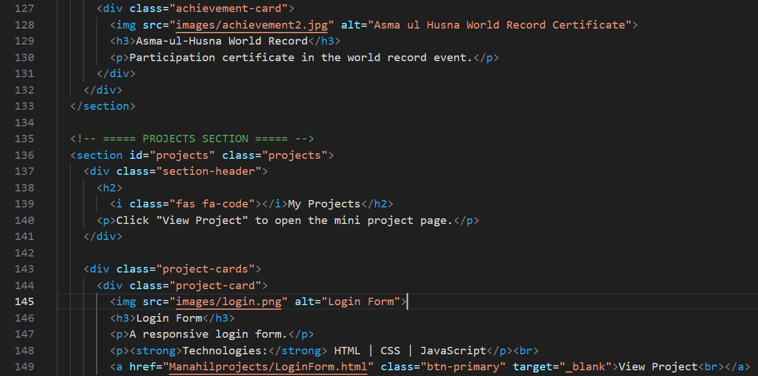
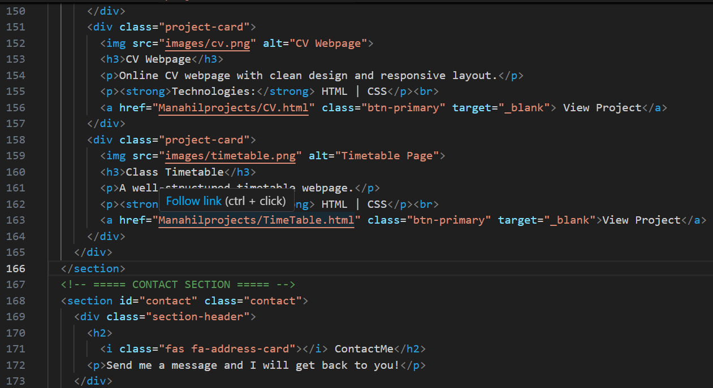
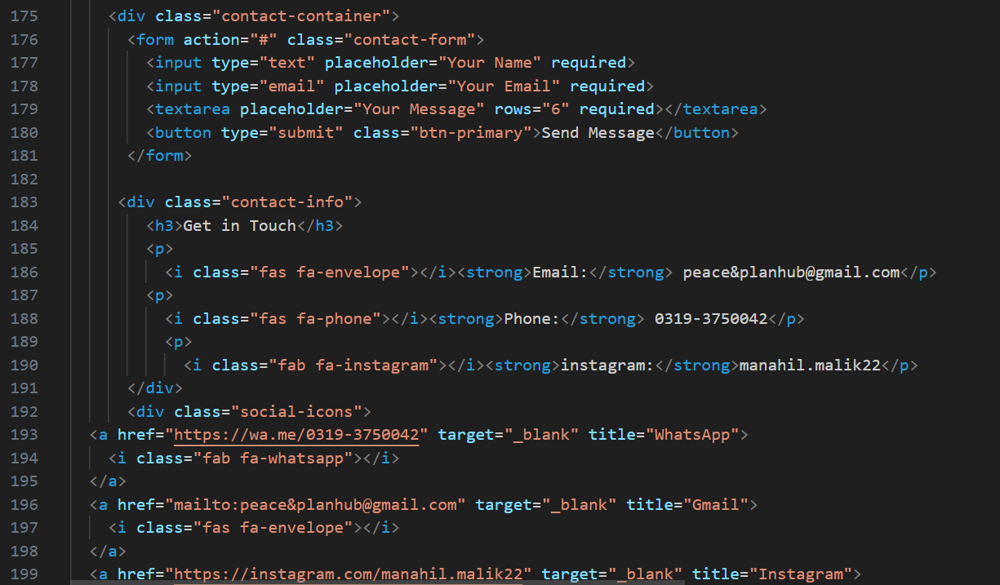
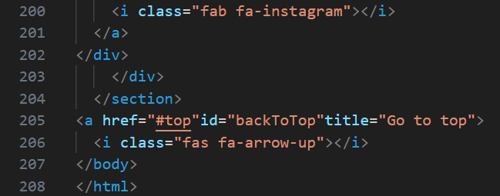
CSS Code:

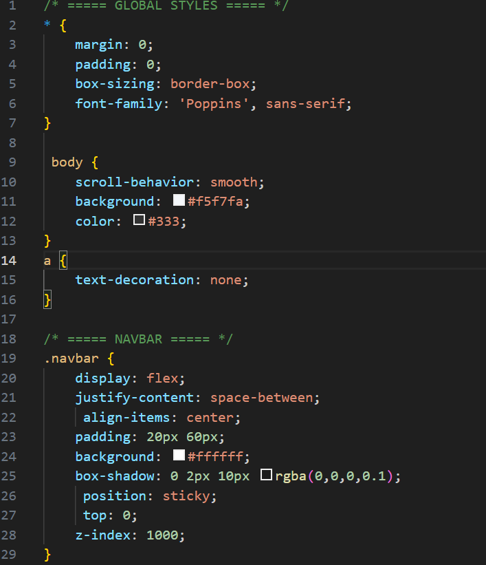
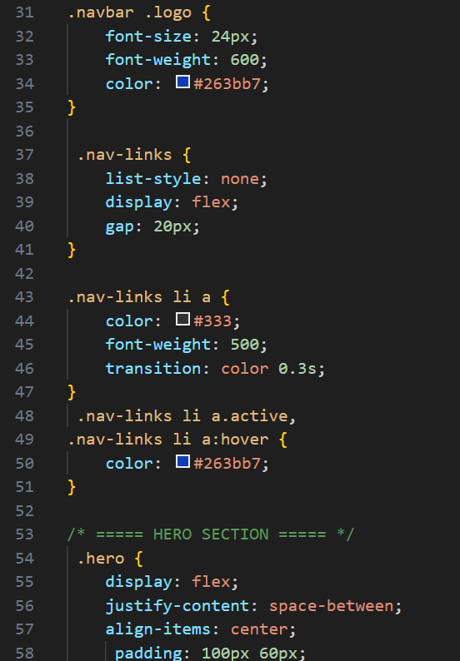
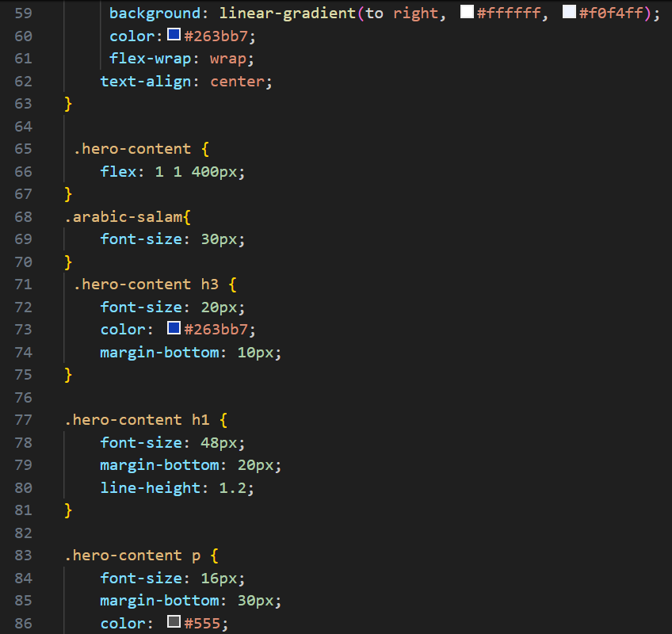
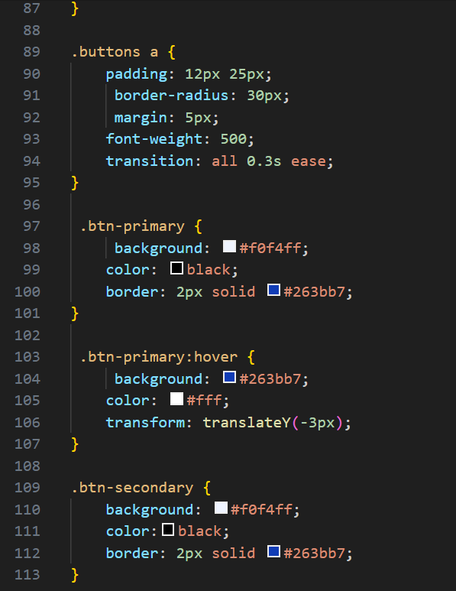
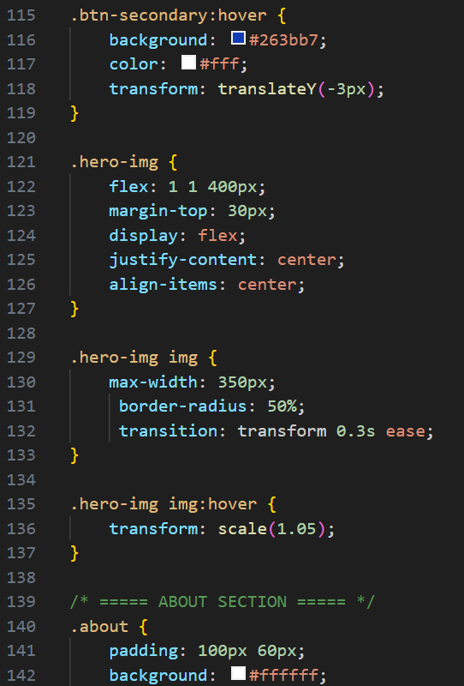
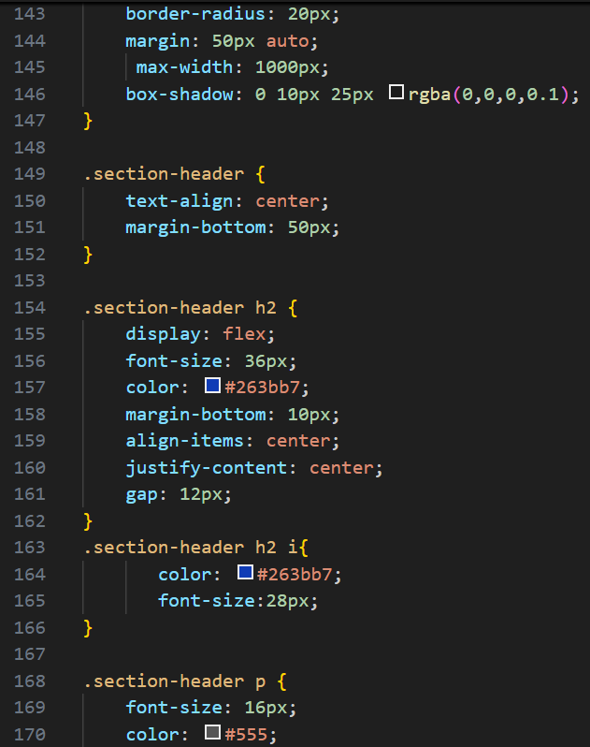
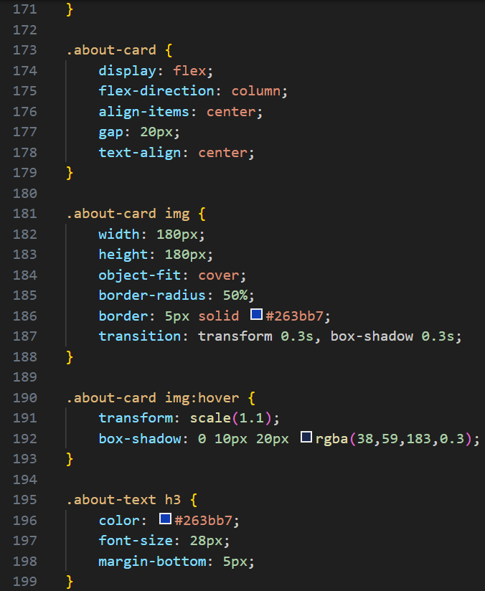
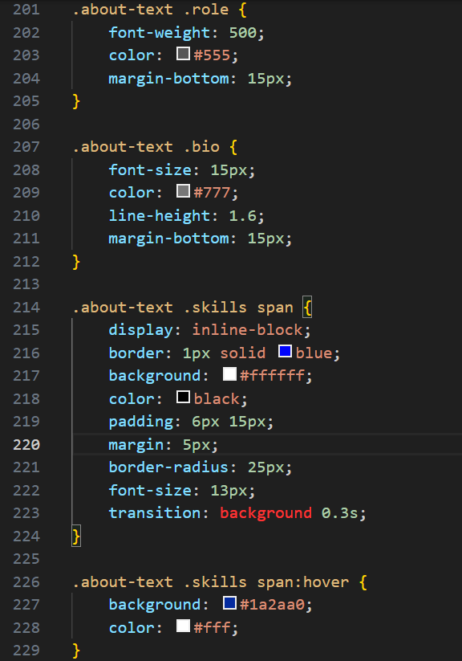
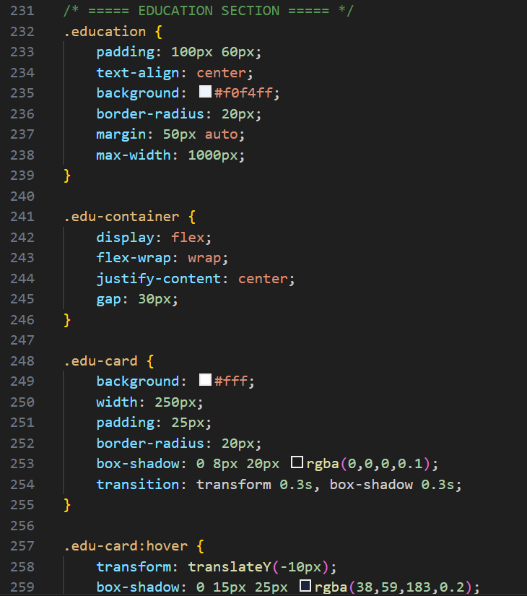
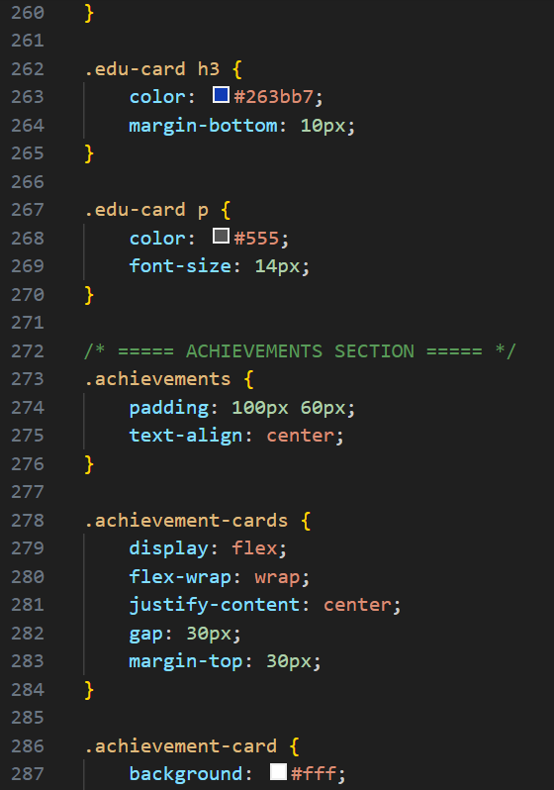
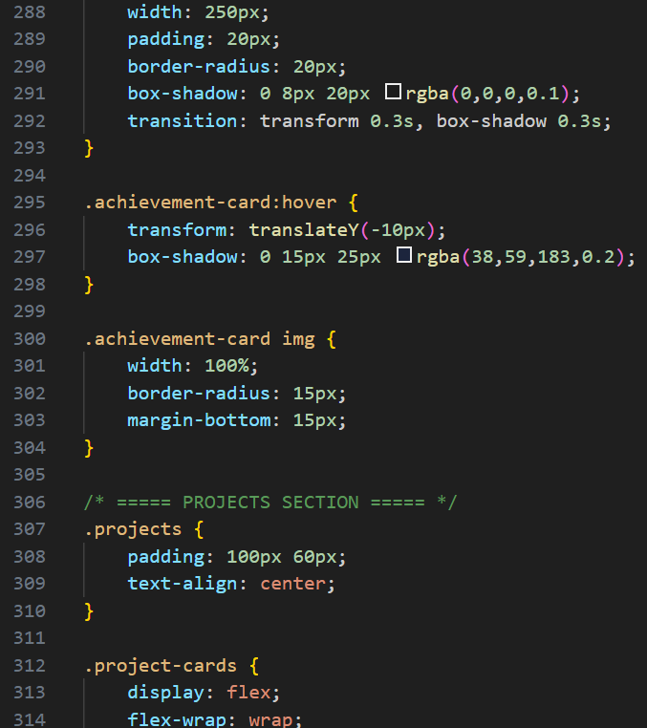
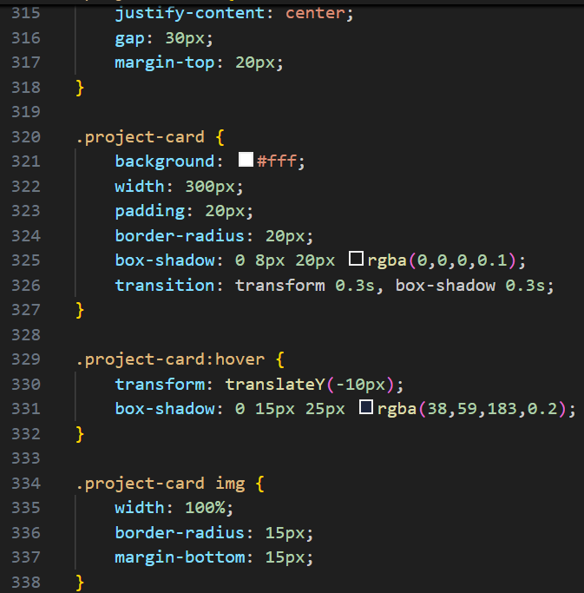
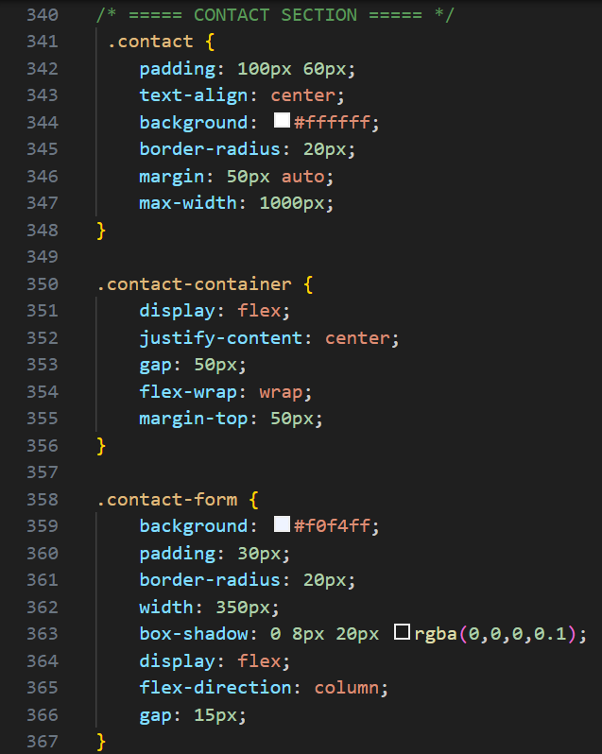
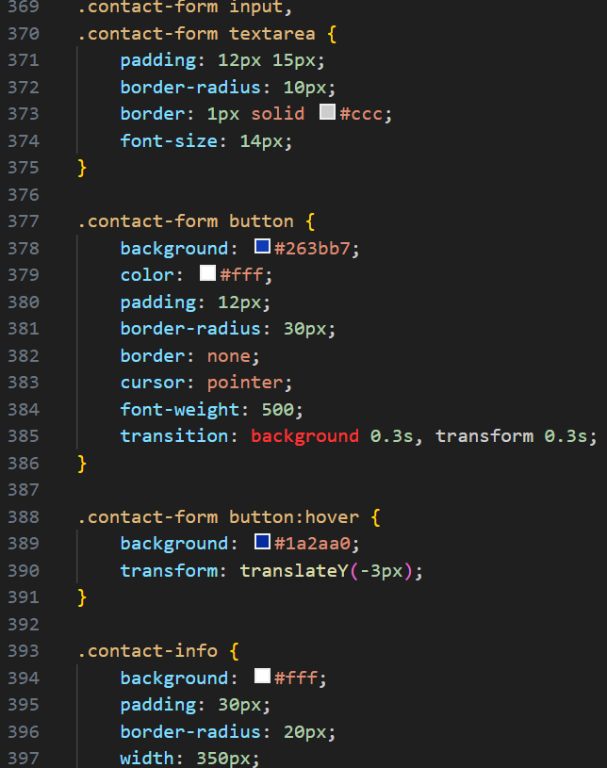
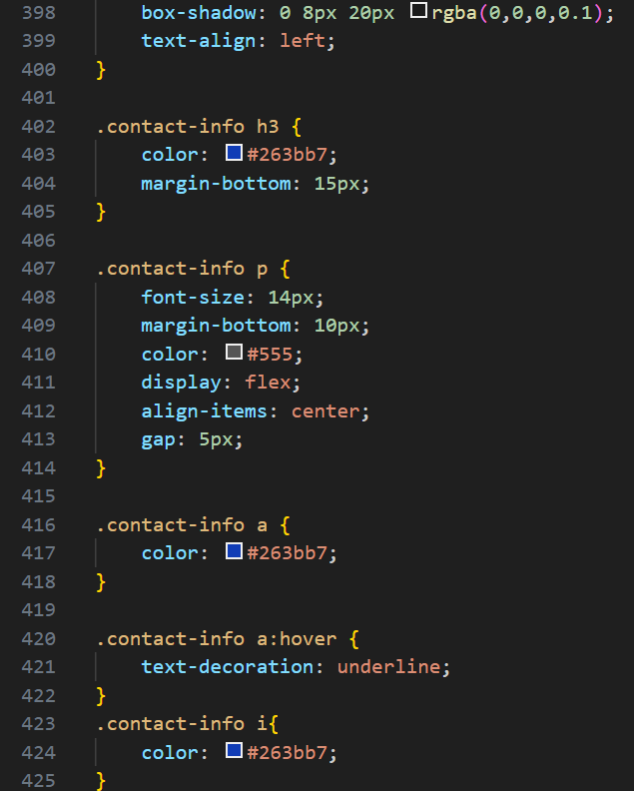
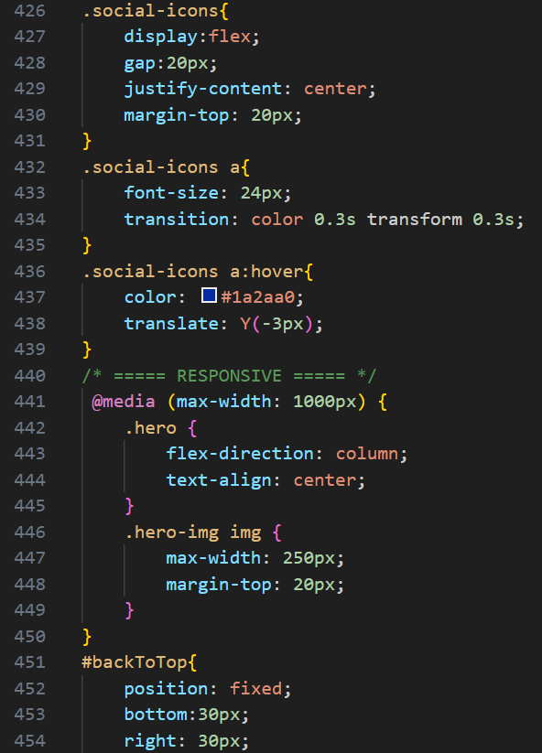
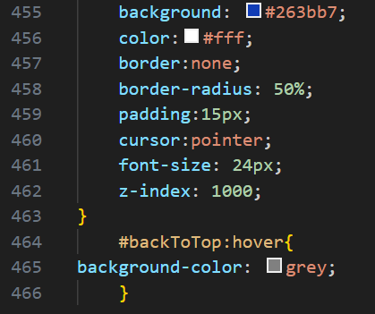
Output:
Navbar:
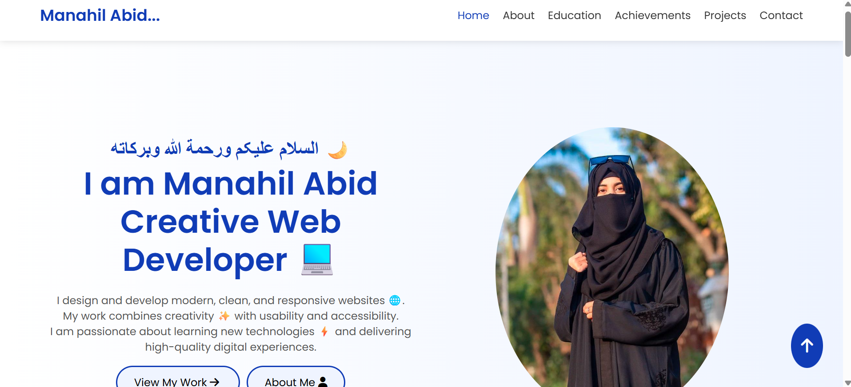
Home Section:
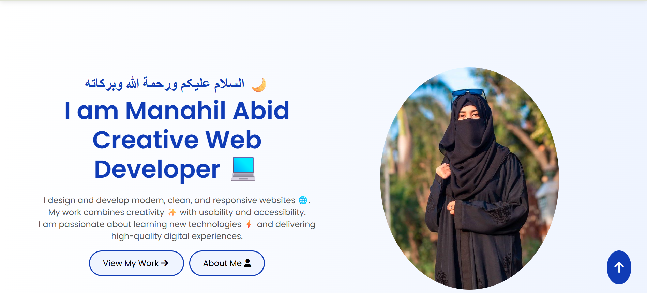
About Me section:
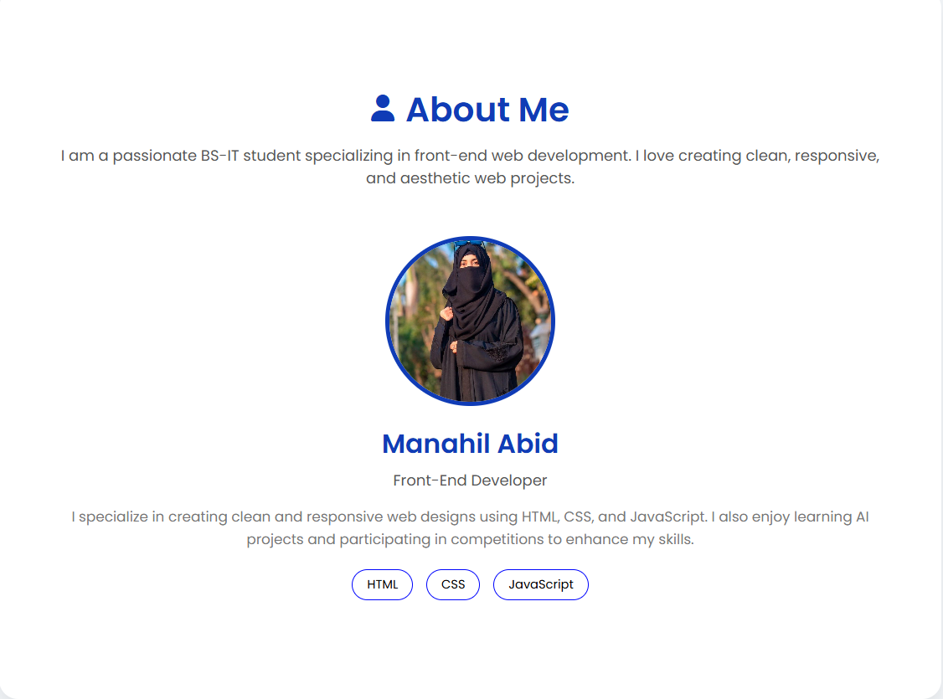
Education section:
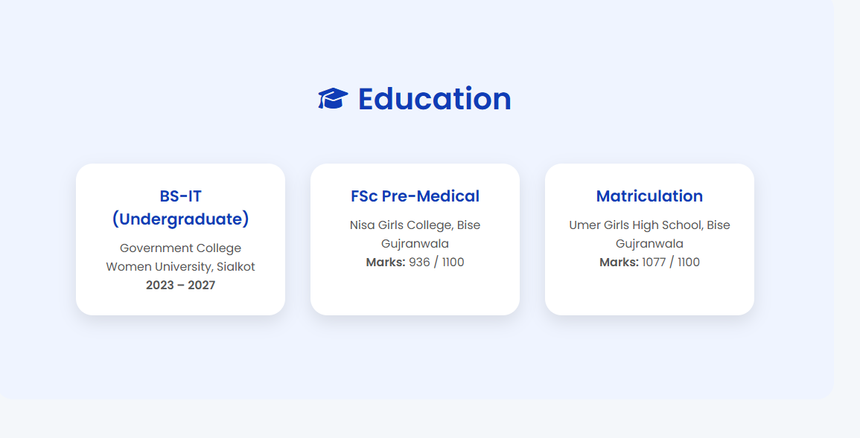
Achievement section:
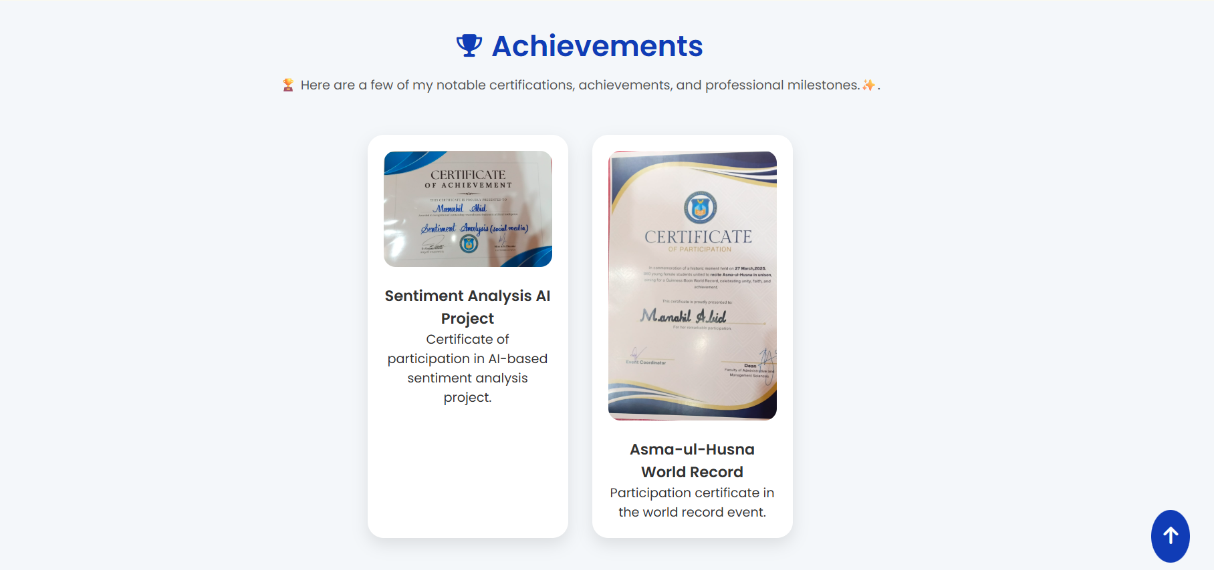
My Projects section:
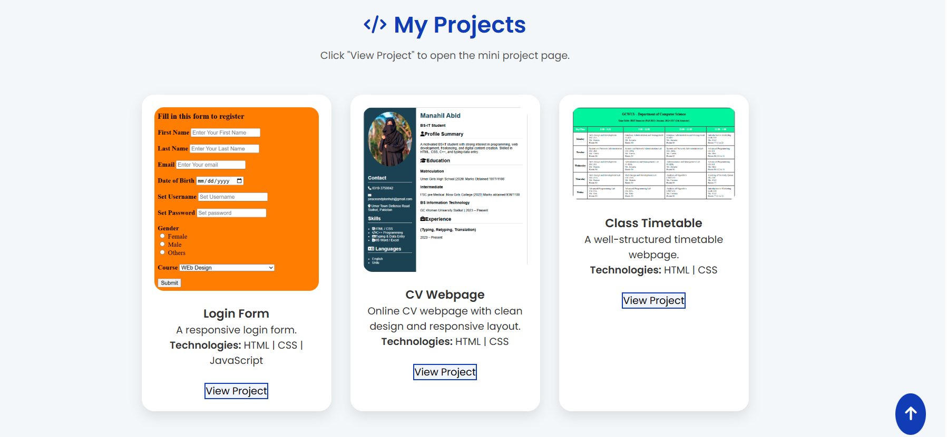
Contact Me section:
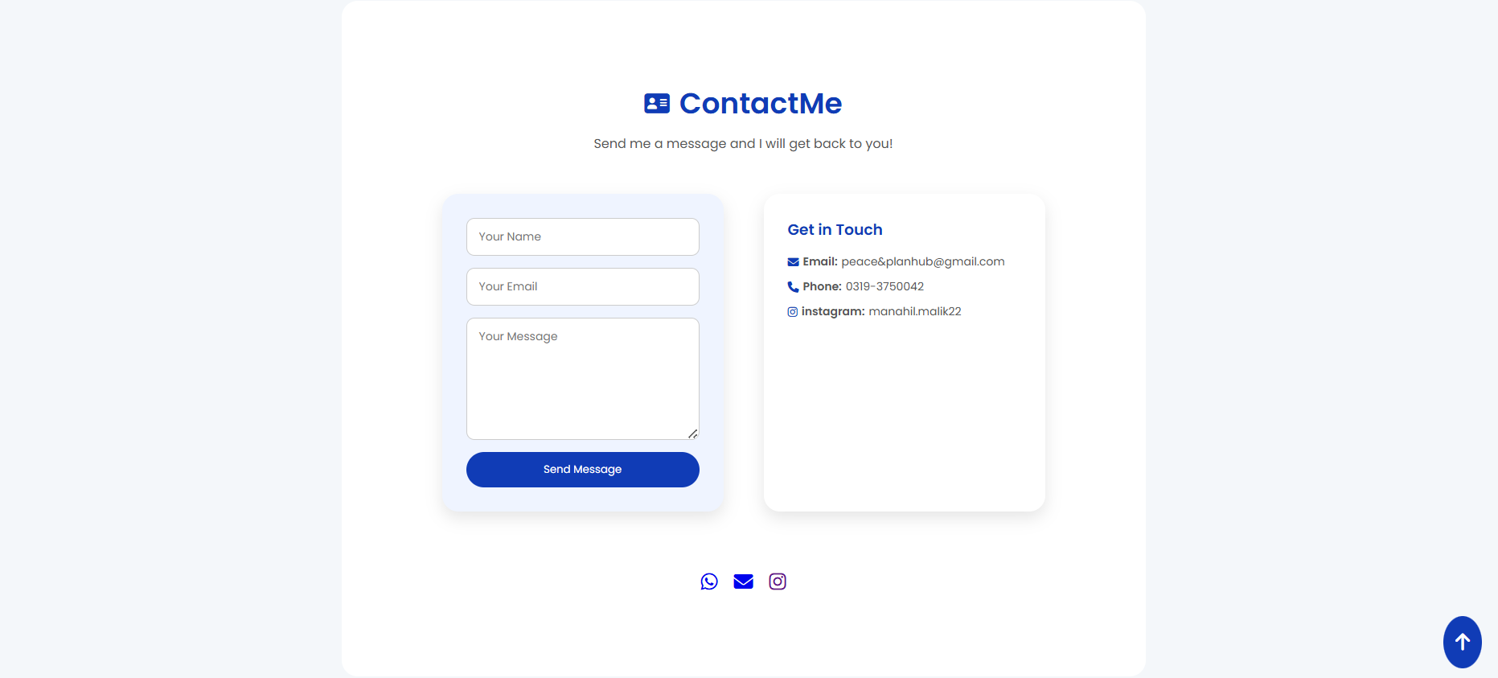
Lab#09
Java script codes
HTML file of lab#9:
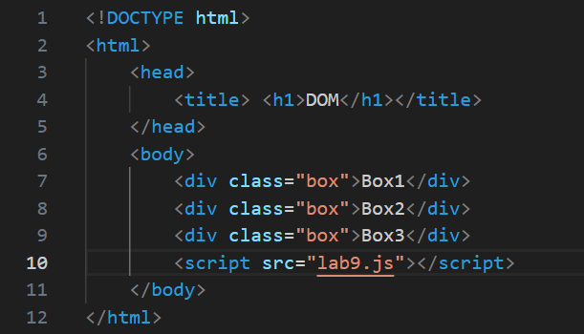
Java Script file:
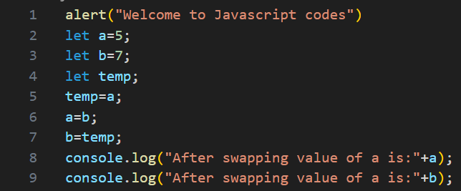
Output:
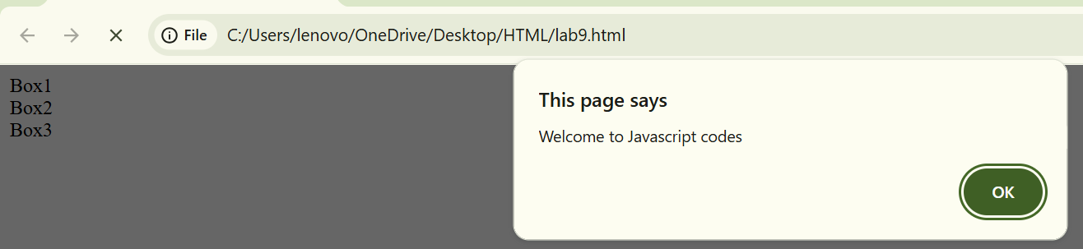
Question#1:
Write a JavaScript program to swap the values of two variables.
Code:

Code detail:
• Initialization:
- let a=5; and let b=7; initialize the two variables with their starting values.
- let temp; declares a placeholder variable to hold a value during the swap.
• The Swapping Process:
- temp=a;: The value of a (5) is stored in temp.
- a=b;: The value of b (7) is assigned to a. Now a is 7.
- b=temp;: The original value of a (stored in temp) is assigned to b. Now b is 5.
• Output:
- The console.log statements display the new values.
Output:
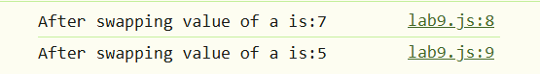

Question#2:
Create a function that accepts a user-defined number and prints its multiplication table.
Code:
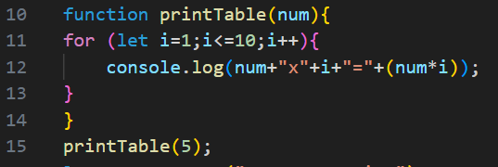
Code Details:
• Function Definition (function printTable(num)):
This line declares a function named printTable that accepts one parameter, num. This num represents the number for which the table will be generated.
• The for Loop:
- let i = 1;: The loop starts at 1.
- i <= 10;: The loop continues as long as i is less than or equal to 10.
- i++: The value of i increases by 1 after each cycle.
• The Output (console.log):
Inside the loop, the program prints a string that combines the input number, the current multiplier (i), and the result of the calculation (num * i).
• Function Call (printTable(5)):
This line executes the function and passes 5 as the input.
Output:
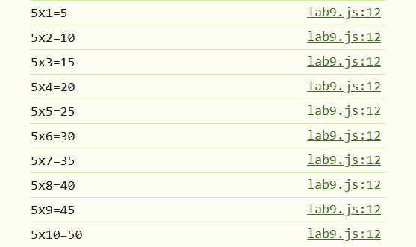

Question#3:
Write a JavaScript program to reverse a given string using a for loop.
Code:

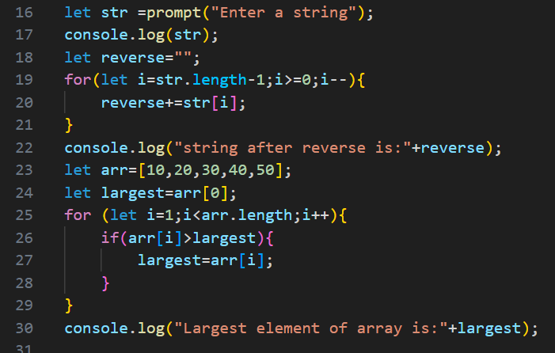
Code Details:
• prompt("Enter a string"):
This opens a popup box in the browser for the user to type in text.
• let reverse = "":
Create an empty "bucket" to hold reversed characters.
• The for Loop Logic:
- Start (let i = str.length - 1): In programming, counting starts at 0. So, the last character of a string is always at the position "length minus one".
- Condition (i >= 0): The loop keeps running until it reaches the very first character (position 0).
- Step (i--): This tells the loop to count backwards by one each time.
• reverse += str[i]: This takes the character at the current position (i) and adds it to reverse string.
Output:
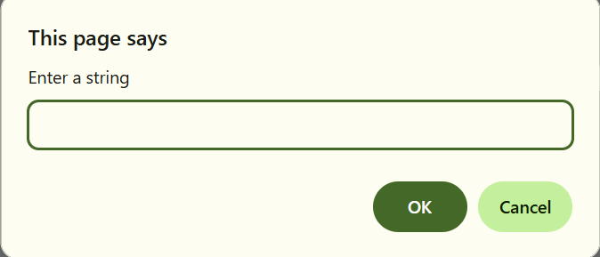
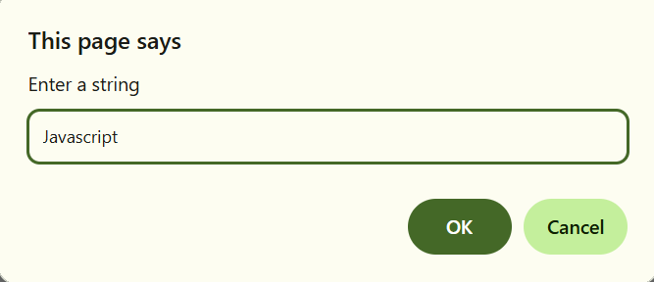
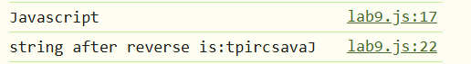

Question#4:
Develop a program that finds and displays the largest number from a given array.
Code:

Code Details:
- let largest = arr[0]: Start by picking the first number (10) and treating it as the current "champion" or largest value.
- The for Loop:
  - Start (let i = 1):Start comparing from the second element (20) because there is already the first one in largest variable.
  - Condition (i < arr.length): The loop runs through every item until it reaches the end of the array.
- The Comparison (if (arr[i] > largest)): For every step, the program asks: "Is this new number bigger than current champion?".
  - If yes, the largest variable is updated with that new value.
  - If no, it moves to the next number without changing anything.
Current Index (i) | Value at arr[i] | Current largest | Action
Start | - | 10 | Initialization
1 | 20 | 10 | 20 > 10, update to 20
2 | 30 | 20 | 30 > 20, update to 30
3 | 40 | 30 | 40 > 30, update to 40
4 | 50 | 40 | 50 > 40, update to 50
Output:

Question#5:
Write a function that takes a number as input and determines whether it is even or odd.
Code:
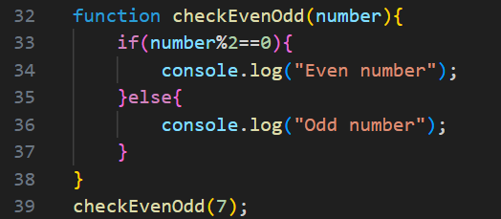
Code Details:
- The Function (checkEvenOdd(number)): This defines a reusable block of code that accepts a single value called number.
- The Modulus Operator (%): This is the key to the logic. It calculates the remainder of a division.
  - Any number divided by 2 with a remainder of 0 is Even.
  - Any number divided by 2 with a remainder of 1 is Odd.
- The if...else Statement:
  - If the condition (number % 2 == 0) is true, it executes the first block and prints "Even number".
  - Otherwise, it skips to the else block and prints "Odd number".
Input Example | Operation (number % 2) | Result | Output
4 | 4%2 | 0 == 0 (True) | "Even number"
7 | 7%2= 3R 1 | 1 == 0 (False) | "Odd number"

Output:

Question#6:
Create a function that accepts a string as an argument and returns the total number of vowels in it.
Code:
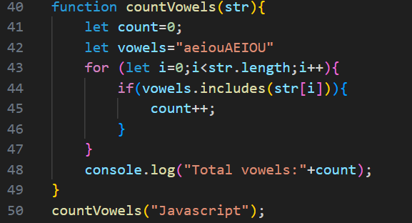
Code Details:
- Initialization:
  - let count = 0;: We start a counter at zero to track how many vowels we find.
  - let vowels = "aeiouAEIOU";: This string acts as a reference library containing all possible vowels in both lowercase and uppercase.
- The for Loop: The loop starts at the first character (index 0) and moves through the string one by one until it reaches the end (str.length).
- Checking for Vowels:
  - vowels.includes(str[i]): For every character in the input string, the program checks if it exists inside our "vowels" reference string.
  - If it is a match, count++ increases our total by one.
- Output: Finally, the program prints the final count to the console.
Output:

Question#7:
Create three <div> elements with a common class name box. Access them using JavaScript and insert unique text into each <div>
HTML Code:

Code Details:
- HTML: Three <div> elements are created with the class name box.
- Lab9.js file is linked with html to which the div are accessed
HTML Output:
Before accessing using java script:
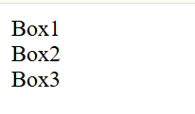
Java Script Code:
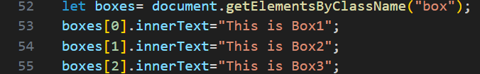
Code Details:
This task involves changing HTML content using JavaScript.
- HTML: Three <div> elements are created with the class name box.
- JavaScript Selection: document.getElementsByClassName("box") creates a list of these elements.
- Unique Text: The innerText of each element is updated by accessing its specific index ([0], [1], or [2]).
Output:
After accessing using java script:
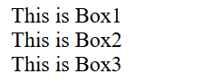

Question#8:
Create an array containing the following company names: "Bloomberg", "Microsoft", "Uber", "Google", "IBM", "Netflix"
Perform the following operations:
  - Remove the first company from the array
  - Remove Uber and add "Xeven" in its place
  - Add Amazon at the end of the array
1.Display array:
Code:
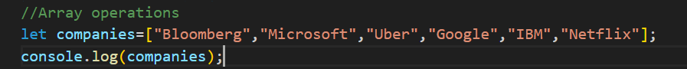
Code Details:
• Creation: An array companies is initialized with names including "Bloomberg", "Microsoft", and "Uber".
• Initial Output: The full list of companies is printed to the console.
Output:
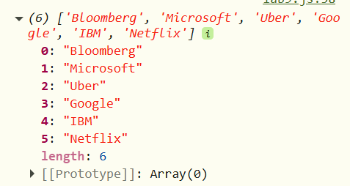

2.Remove first company:
Code:
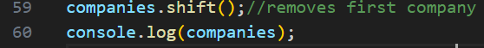
Code Details:
- To remove the very first element ("Bloomberg") from the array, the shift() method is used.
Output:
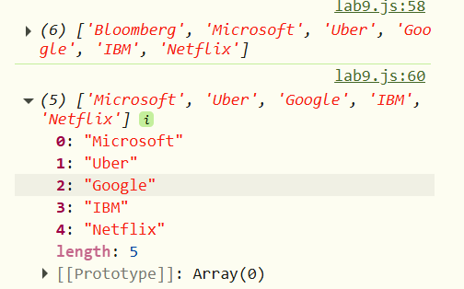

3.Replace Uber with Xeven:
Code:
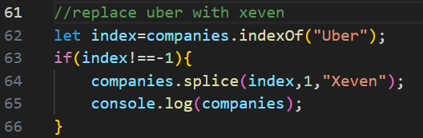
Code Details:
In JavaScript, the splice() method is a powerful tool used to change the contents of an array by removing or replacing existing elements.
Code Breakdown: companies.splice(1, 1, "Xeven");
This line performs the replacement of "Uber" with "Xeven" .
- 1 (First Parameter - Index): This is the starting position. Since the first company ("Bloomberg") was already removed using shift(), "Uber" moved from index 2 to index 1.
- 1 (Second Parameter - Delete Count): This tells JavaScript to remove exactly one element starting from that index (which removes "Uber").
- "Xeven" (Third Parameter - Items to Add): This is the new string being inserted into the gap left by the removed element.
Output:
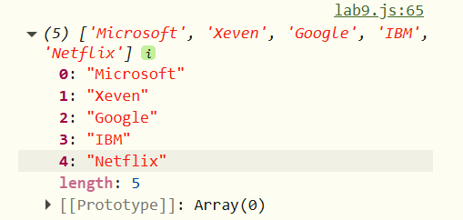

4.Add Amazon at end of array:
Code:
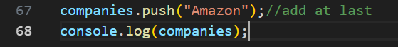
Code Details:
"Add Amazon at the end of the array," the code companies.push("Amazon"); works as follows:
- companies: This is the name of array that currently contains names like "Microsoft", "Xeven", "Google", "IBM", and "Netflix".
- .push(): This is a built-in array function that targets the very last position of the list.
- ("Amazon"): This is the string value passing into the function to be added to the array.

Output:
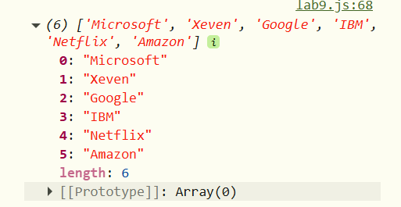
THE END

